NSW Cabinets for surplus or recycling:
March 2026
Measurements in inches.
- Tall metal herbarium cabinets with shelves, dimensions 31” W X 20 5/8” D X 78 3/4” H, location in unconditioned space in NSW.
  - 10 cabinets (2 per pallet).
  - 1 loose cabinet
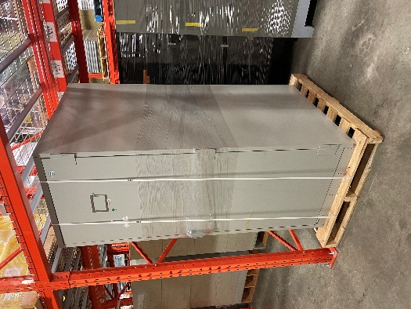

- 1 loose metal cabinets without handles with 5 thin drawers. Location NSW unconditioned space (temporarily on a cart). cabinet dimension 54” x41½” x15 ½”
  - Light grey 4 stacked cabinets with handles+ base 54” x41½” x69”. Drawers 2 5/8”tall.

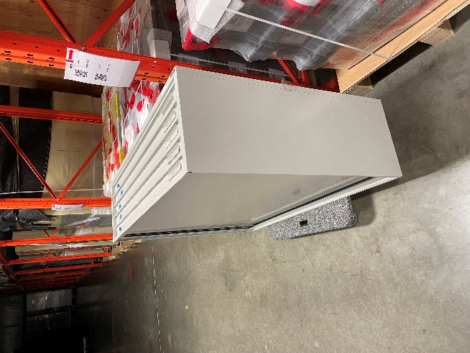

- 2 set of metal cabinets without handles stacked 3 high with 5 thin drawers each.
Total of 6 5-drawer cabinets. Location NSW unconditioned space V07a.
  - Beige & Grey 3 stacked cabinets without handles+ base 48” x37½” x65”.
    - Base 48” x37½” x 9”
    - Each cabinet dimension 48” x37½” x 18 ¾”
    - Drawers 3 ½” tall
  - Grey 3 stacked cabinets without handles+ base 48” x37½” x65”.
    - Base 48” x37½” x 9”
    - Each cabinet dimension 48” x37½” x 18 ¾”
    - Drawers 3 ½” tall

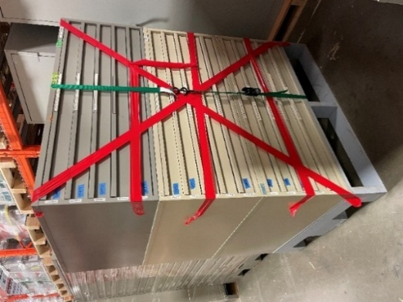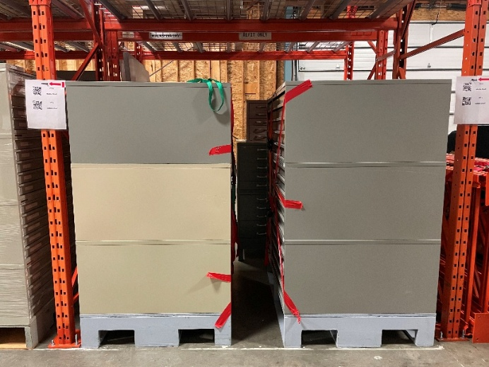

- 1 Set of mixed metal cabinets with handles stacked 3 high with 5 drawers each.
Total of 3 5-drawer cabinets. Location NSW unconditioned space W01a.
  - 2 Grey & 1 Brick stacked cabinets with handles+ base 47”x36”x66”.
    - Base 47”x 36”x 9”
    - Brick cabinet dimension 40 ½” x 26” x 17”. Drawers 3” tall.
    - Grey cabinets dimensions 47”x36”x20”. Drawers 3 ½” tall

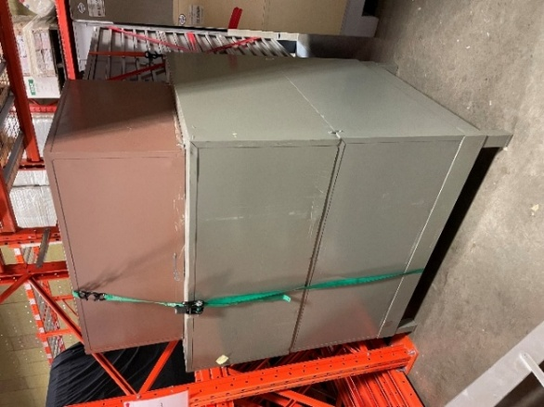

- 1 Set of mixed metal cabinets with handles stacked 2 high with 5 drawers each. Total of 2 5-drawer cabinets. Location NSW unconditioned space W02a.
  - 2 Grey & 1 Cream stacked cabinets with handles+ base 47”x36”x46”.
    - Base 47”x 36”x 5 3/4”
    - Cabinets dimension 47”x36”x20”. Drawers 3 ½” tall.

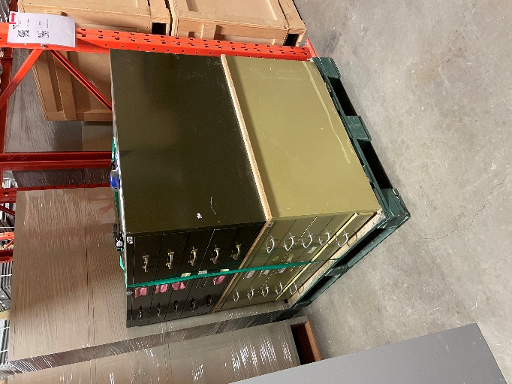

- Metal cabinets loose drawers on 48”x40” pallets. Total of 8 pallets. Location NSW unconditioned space top shelves.

These drawers are for 46x28x42 Birds and Mammals cabinets (see picture beside drawers)
