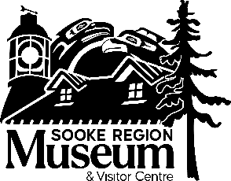
Highlights from Voices of the Community: Insights from a Community Dialogue
Sooke Region Museum & Visitor Centre
Community Engagement Project Report.
Sooke Region Museum; November 2025.
Engagement methods and responses:
- 1,909 participants responded to the museum’s invitations for feedback through an online survey, focus groups, open house, and other participation events.
- 1,589 participants provided feedback through 21 in-person activities (focus groups, activities at the museum, and other community events). 320 participants completed the survey,
Top findings:
- The museum is highly valued by the community for its role as keeper and sharer of stories of Sooke and the surrounding region.
- Overall impression of the Sooke Region Museum:
45% very positive; 43% positive; neutral 11%; 1% negative or very negative
- The museum staff are praised for their helpfulness, professionalism, and welcoming attitude.
- Program participation (events, workshops, talks, and tours) is the primary motivation for visiting the museum; people appreciate the opportunity to learn something new.
Key themes from the responses:
- Cultural representation is important to the community. Present more Indigenous stories, including history, art, culture, traditional foods and medicines, Indigenous/settler relationships, and how to support reconciliation.
- Update and improve exhibits to make them more interactive, include a mix of early and modern history, add audio/visual elements, rotate artifacts, add diverse perspectives, expand exhibits on natural history, and spread information and exhibits to other areas in the region.
- Incorporate storytelling in all aspects of museum programs and exhibits, and add more learning workshops, talks and events. Ideas included guided nature walks, more information on and access to the saltwater marsh, traditional skills workshops, and more programming suited to various age groups, especially children.
- Improve accessibility with expanded parking, more accessible-friendly grounds and buildings, and expanded operating hours.
- Continue connecting with the community through presence at community events, developing exhibits and programming throughout the region, deepening relationships, and improving public communications.
Commitment to Action:
The Sooke Region Historical Society board and Sooke Region Museum staff are very grateful for the ideas shared. We will implement recommendations, where feasible, to support and inform strategic and operational planning. Some of the ideas put forward by the community, while desirable, may be out of current reach and will depend on available resources. We will keep the community informed of progress.

