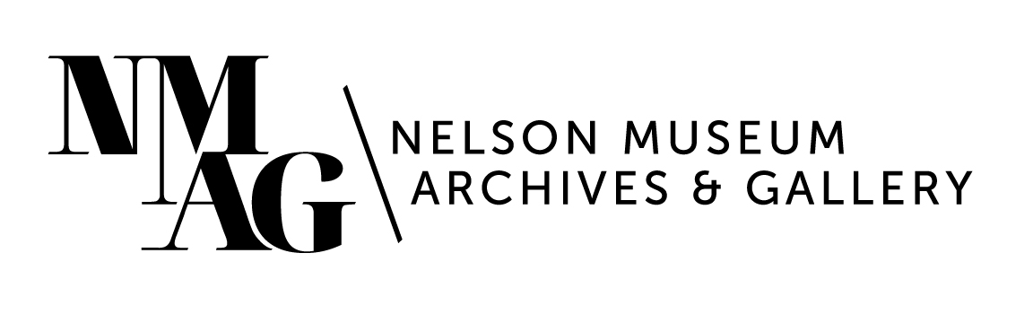

Press Release

Media contact:

Stephanie Delnea, Communications and Development Manager

Nelson Museum, Archives & Gallery

communications@nelsonmuseum.ca

250.352.9813 x. 204

For immediate release

Into the woods: forest stories told through art and artifact at the Nelson Museum this summer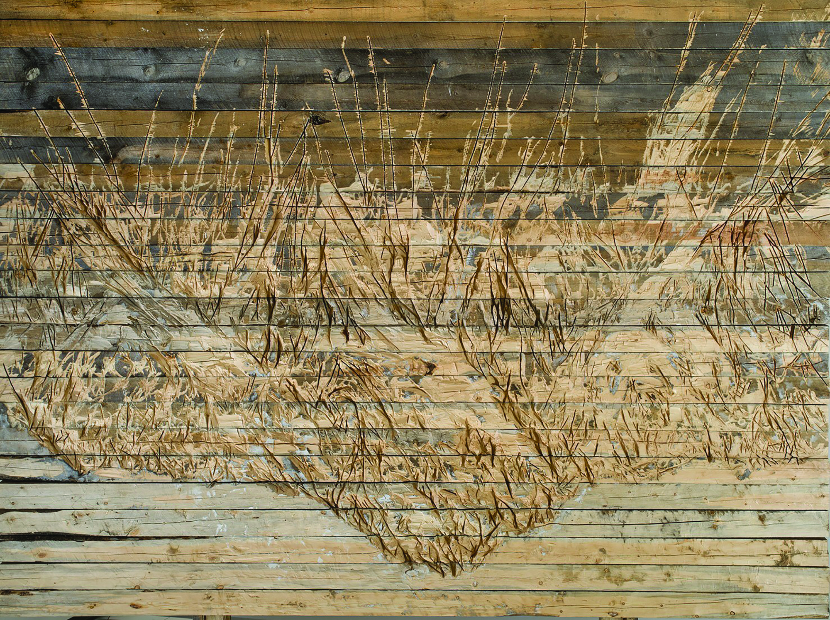

Nelson, BC (June 18, 2025) - This summer, the Nelson Museum, Archives & Gallery invites visitors to experience the forest like never before—through the hands of artists, the lens of history, and the echoes of culture.

*WOOD* is a visually striking group exhibition featuring eight acclaimed contemporary artists from across Canada. From traditional birch bark biting to immersive audio/visual installation, sculpture, weaving, and carving, these artists showcase the incredible versatility of wood as both medium and message. Participating artists include Peter von Tiesenhausen, Samuel Roy-Bois, Xiaojing Yan, Rita McKeough, Susan Point, Pat Bruderer, Stephen Noyes, and Nadia Myre. Together, they demonstrate how wood can shape—and be shaped by—cultural, environmental, and artistic identities.

### *Relief*, Peter von Tisenhausen, 2012. 192”x144”, stacked carved timber wall. Photo courtesy of the artist.

The exhibition opens with a special artist panel on Friday, July 11, featuring many of the eight artists in conversation. A full-colour exhibition catalogue will also be released during the run of the show, offering deeper insight into the works and the ideas behind them.

The artists featured in *WOOD* bring a wide range of perspectives and practices to the exhibition. Peter von Tiesenhausen is an Alberta-based artist known for his land-based works and environmental stewardship; his practice blends sculpture, installation, and performance to address themes of time and transformation. Samuel Roy-Bois, originally from Quebec and now based in British Columbia, is celebrated for his large-scale installations that blur the boundaries between art, architecture, and everyday life. Xiaojing Yan, a Chinese-Canadian artist, combines traditional Chinese materials like lingzhi mushrooms and ink with contemporary sculptural forms to explore cultural identity and transformation. Rita McKeough, a beloved figure in Canadian media art, has spent decades creating immersive installations and sound works that fuse activism, humour, and empathy. Susan Point, a Coast Salish artist from Musqueam, is internationally recognized for revitalizing Coast Salish design through contemporary wood carving, serigraphy, and public commissions. Pat Bruderer (Half Moon Woman) is one of the few remaining practitioners of the ancient Indigenous art of birch bark biting and is a passionate cultural educator and knowledge keeper. Stephen Noyes blends traditional woodworking with modern design, crafting refined objects that speak to place and material and using cedar gathered from both British Columbia and Washington state to craft the burden basket on display. Nadia Myre, a member of the Kitigan Zibi Anishinabeg First Nation, is a multidisciplinary artist whose work in beading, sculpture, and participatory projects has been shown around the world, including a retrospective currently showing at the National Gallery of Canada, and the Biennale of Sydney.

“The incredible challenge and compensatory reward of group exhibitions that illustrate the diversity of any given medium, such as *WOOD*, is that a vast landscape of past and present, traditional and contemporary, political and personal, and all points in between starts to be seen,” says Nelson Museum Curator Arin Fay, “like the forest for the trees.”

Running concurrently in Gallery B is *Deep Roots*, an art/history exhibition that looks at the community’s connection to the forest, past and present. Through archival photographs, artifacts, contemporary artworks, film, and written reflections, *Deep Roots* reveals the ongoing relationship between people and place—and the many ways that connection has evolved over time.

Together, *WOOD* and *Deep Roots* invite visitors to reflect on the forest not just as a resource, but as a source: of creativity, memory, meaning, and identity. These exhibitions are more than the sum of their parts—they are a reminder that these multi-faceted stories, rooted in wood, are still growing.

With special thanks to the Canada Council for the Arts, the Province of BC, the BC Arts Council, the City of Nelson, and the Nelson & District Credit Union for funding these exhibitions. For more information visit nelsonmuseum.ca and sign up for the monthly newsletter.

-30-