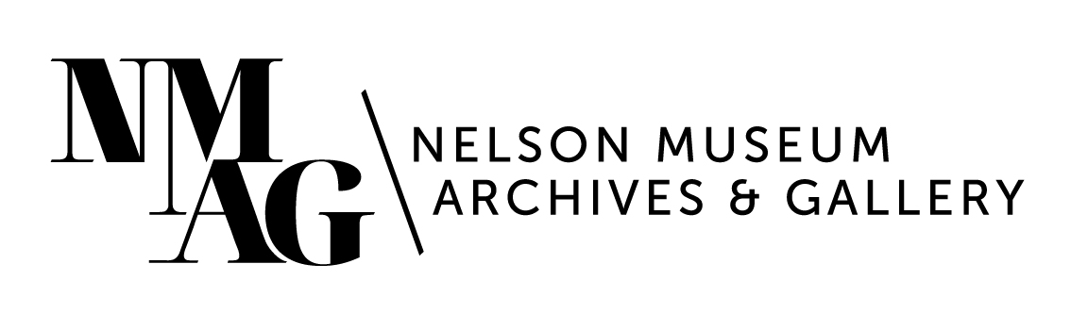

Press Release

Media contact:

Stephanie Delnea, Communications and Development Manager

Nelson Museum, Archives & Gallery

communications@nelsonmuseum.ca

250.352.9813 x. 204

For immediate release

A summer of forest stories at the Nelson Museum: *Deep Roots* opens Friday, June 6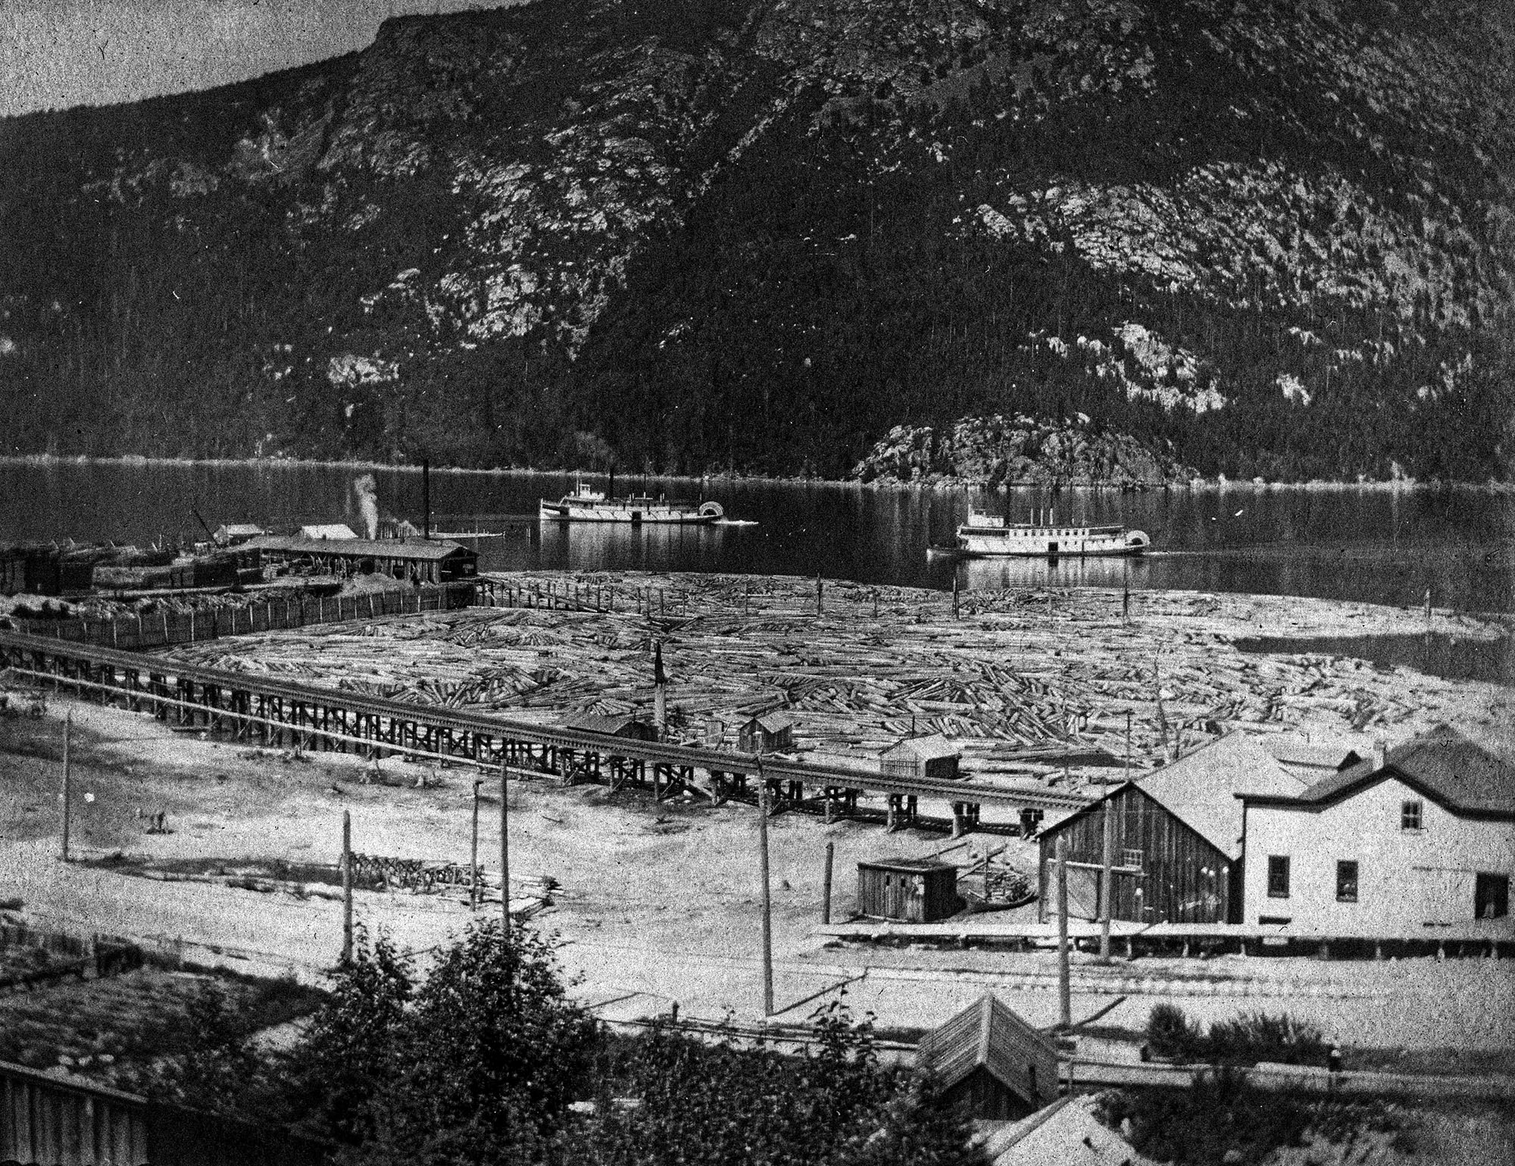

Nelson, BC (May 26, 2025) - Since time immemorial the forest has provided; homes and medicine, deep shade and stable ground, and resources from which we have created a legacy of economic opportunity. The Nelson Museum’s latest exhibition *Deep Roots* (June 7 to September 13) unearths the complex story of the Kootenay forest and our community’s relationship to the environment, both past and present.

*Deep Roots* explores the history of the West Kootenay forestry industry, the attitudes and actions of our community, forest resources, and the continuing importance of forest management to people, the environment and the economy. This complex story is told through juxtaposition—from two photographs of Kootenay Lake and the Nelson waterfront sit side by side, one from the spring of 2025 by Louis Bockner, and the other an image from the Shawn Lamb Archives from 1899; to a towering mural of the lofty white pines acting as the backdrop to a singular matchbox. It also encompasses industry growth and the protests that followed; treeplanters and fire spotters. Artwork from Emma Noyes, Bridget Corkery and Fern Helfand hangs alongside vintage felling tools, archival images, and signage from the Collection, and visitors are invited to take a tree sapling with them to plant, donated by PRT Harrop Nursery..

Nelson waterfront, September 1901. From the Shawn Lamb Archives at the Nelson Museum, Archives & Gallery.

“There is a duality to this story that appears many times throughout history,” says Nelson Museum Archivist and Collections Manager Jean-Philippe Stienne, who led the curation of *Deep Roots*. “We all use the resources of the forest but also wish to protect them for ourselves and future generations. The challenge is to strike a sustainable balance so that we can achieve this.”

*Deep Roots* opens on Friday, June 6 at 7pm. Related programming in July will include a panel discussion featuring former MLA and logger Corky Evans, West Kootenay Watershed founder and former RDCK Director Ramona Faust, and professional forester and forest ecologist Herb Hammond. The discussion will be moderated by strategic resource planning consultant John Cathro, who has worked professionally in the resource sector in British Columbia for over 30 years. A complete list of panelists, as well as date and time details will be posted on the Nelson Museum’s website as they become available.

Showing concurrently with *Deep Roots* is *WOOD* (July 12 to October 18) in Gallery A; a group exhibition featuring the works of Peter von Tisenhausen, Samuel Roy-Bois, Stephen Noyes, Xiaojing Yan, Rita McKeough, Susan Point, Pat Bruderer, and Nadia Myre. The show is centred around each artist’s exploration of wood as a creative medium.

For more news, exhibition details, and program announcements, please visit nelsonmuseum.ca and subscribe to the NMAG monthly newsletter.

-30-