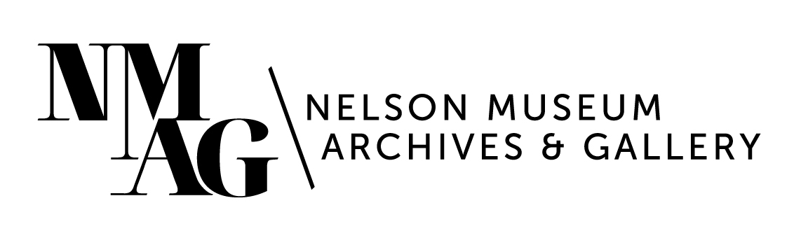

Press Release

Media contact:

Stephanie Delnea, Communications and Development Manager

Nelson Museum, Archives & Gallery

communications@nelsonmuseum.ca

250.352.9813 x. 204

For immediate release

David Garneau’s *Dark Chapters:* A still life exhibition that speaks volumes - opening Friday, March 21 at the Nelson Museum

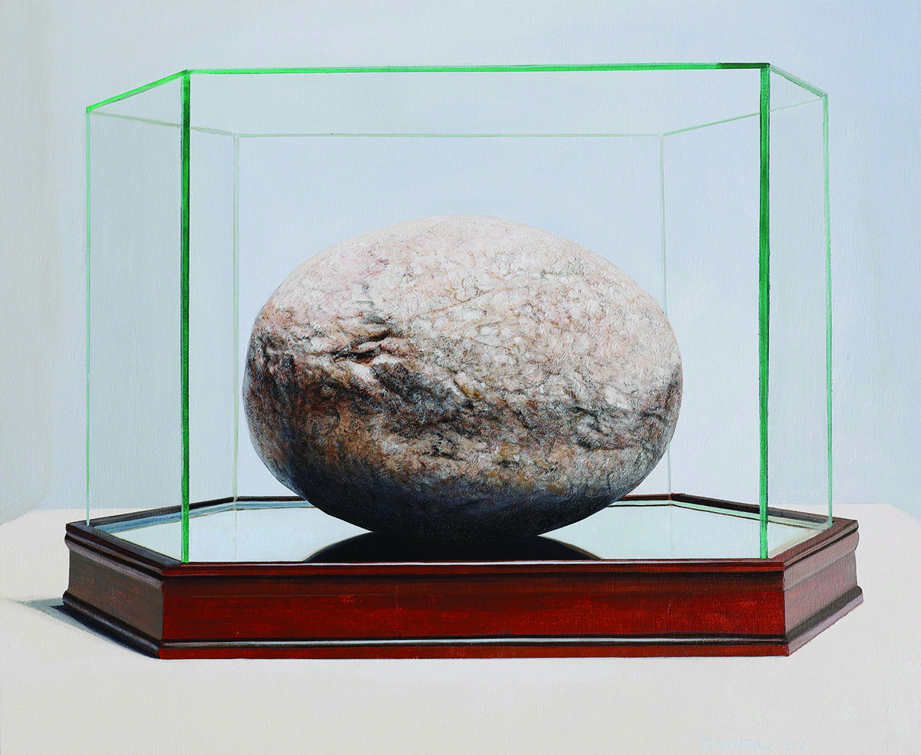

Nelson, BC (March 13, 2025) - Rocks and books and bones, shadows and light, and the balance between these things; studied in isolation and interpreted by 17 leading artists, essayists, poets, and academics from coast to coast, and presented through the dual lens of publication and a touring exhibition—this is David Garneau’s *Dark Chapters*.

The subject matter of Garneau’s still life paintings include everyday objects combined with powerful symbols of his Indigenous heritage, such as a Métis sash and burning sweetgrass. As with traditional still life, the relationship of the objects provides the context, however Garneau adds another profound layer of meaning through the naming of the pieces, with titles like *Future Portrait of the Artist* (a skull on a plinth) and *Visiting a Relative in the National Gallery* (a large display case covered in white cloth). The works are laden with possible interpretations.

*David Garneau, “Suffocating Grandfather”, 2022, acrylic on panel, 61 x 50.5 cm*

Garneau provided no additional context, interviews, or explanation, asking the writers to rely instead on their own lived experiences as guidance. “The risks are numerous. Some writers are likely to create meanings that do not rhyme with the artist’s intentions,” writes Garneau at the onset of the project in 2022. “At the same time, they might generate fresh ideas that cause me to rethink my work and produce new paintings that reflect or contend with the critiques.”

The result is a stunning collection of essays, poetry, and anthropological study from contributors including Fred Wah, Susan Musgrave, Paul Seesequasis, David Howe, Rita Bouvier, Jesse Wente, Billy-Ray Belcourt, Peter Morin, and more. The *Dark Chapters* exhibition premieres at the Nelson Museum, Archives & Gallery on Friday, March 21 at 7pm, featuring a discussion with Garneau and Wah about the origins and process of the project.

Every artwork from the *Dark Chapters* book will be on display, alongside the texts they inspired. Viewers will experience the conversation between visual art and the written word, engaging directly with the layered meanings of each piece.

“Garneau has subverted the still life tradition in meaningful ways, with both serious and sarcastic combinations that carry complex cultural conversations,” says Nelson Museum Curator Arin Fay. “The book that accompanies the exhibition *Dark Chapters: Reading the Still Lives of David Garneau* is intended to inspire, educate and pay homage to the works, giving voice to the complexity and expansiveness of visual and literary language, and the power and importance of perspective.

“We are excited for our members and visitors to experience this exhibition and come to their own conclusions and contributing to the fascinating conversation that David has created.”

The thread tying the diverse writings together is a shared appreciation for Garneau and his work, and for the opportunity to engage in such a unique conversation, which has time and space to continue: was Garneau’s initial outlook correct? Has this experience changed the way he interprets his own process? Was it worth the risk?

“What an invitation, to be a small part of this incredible creative enterprise with so many people,” says contributor Rita Bouvier, “to hear all the voices and to see old friends and make new ones, and now, to sit quietly with*Dark Chapters* and to read and re-read every piece carefully. All I can muster is nanâskomowin—thankfulness to have been a part of it all.”

The March 6 book launch at the Mackenzie Art Gallery in Regina, SK, was an unforgettable experience, setting the stage for the exhibition’s premiere at the Nelson Museum. Twelve of the 17 contributors were in attendance; reading from their works and evoking emotional responses from the audience bringing them from raucous laughter to the brink of tears.

Special thanks to the Canada Council for the Arts for funding the *Dark Chapters* project, and to the University of Regina Press for partnering with the Nelson Museum to see this project to fruition.

David Garneau (Métis) is a Professor of Visual Arts at the University of Regina. He is a painter, curator, and writer who engages creative and critical expressions of Indigenous contemporary ways of knowing, being, and doing. In 2023, he received the Governor General’s Award in Visual and Media Art: Outstanding Achievement and was inducted into the Royal Society of Canada.

For more information on the exhibitions, programs, and events at the Nelson Museum, visit nelsonmuseum.ca

-30-