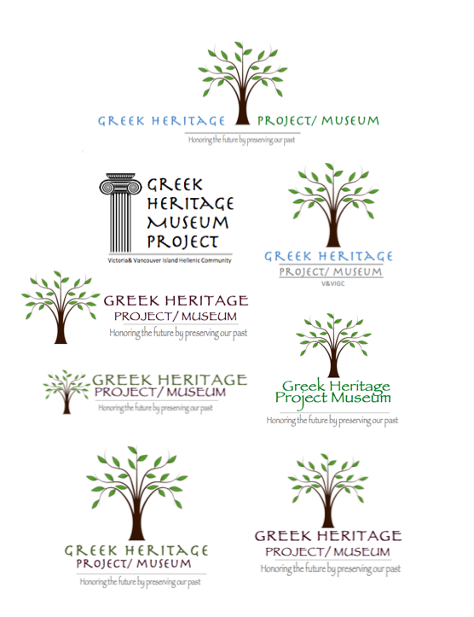 

Victoria & Vancouver Island

Greek Community Society **Museum Assistant**

(**2 positions** subject to funding from Young Canada Works)

**Salary** = $22.00 an hour; **40 hours** per week for **16 weeks**.

**Start date:** May 12, 2023. **End date:** Sept 1, 2023.

**Project and Tasks:**

Genealogical Research:

1) consolidate and digitize existing genealogy of members of the Victoria and Vancouver Island Greek community; 2) digitize/accession new genealogical information/artifacts 3) create digital and/or print presentations of genealogies and artifacts for display at Greek Fest 2025; 4) upload genealogical videos and digitized artifacts to the museum website; 5) better understand the intricacies of archival research and information/ artifact processing, particularly across cultural communities. Other duties will include, for example, regular ongoing accessioning, research on families and artifacts as well as social/ cultural contexts, and visitor relations at the museum. Assistants must be available to work at Greek Fest 2025 during the last two weekends in August.

**Qualifications:**

-Completion of **2nd year** post-secondary studies in History, Fine Arts, Anthropology, Archaeology, Museum/Archival Studies, modern or classical literature(s), Greek and Roman studies, Education, Communications or other areas of the Humanities or related fields.

-Between 16 and 30 years of age at the start of the employment; a Canadian citizen, permanent resident, or person to whom refugee protection has been conferred under the Immigration and Refugee Protection Act; have a valid Social Insurance Number at the start of employment and are legally entitled to work in Canada.

-Excellent writing and editing skills, MS Office Suite (skills), and ability to use scanners and cameras. Experience working collaboratively is preferred but not mandatory.

-Applicants from equity-deserving groups preferred. Modern Greek an asset but not required.

**To Apply:**

By **April 18, 2025,** send cover letter, resume and 1-page discussion about your interest in cultural diversity to:

Greek Heritage Project Museum [greeksummerjob22@gmail.com](mailto:greeksummerjob22@gmail.com)

or 4648 Elk Lake Drive, Victoria BC V8Z 5M1.

*Thank you for your interest. Only applicants selected for interview will be contacted.*