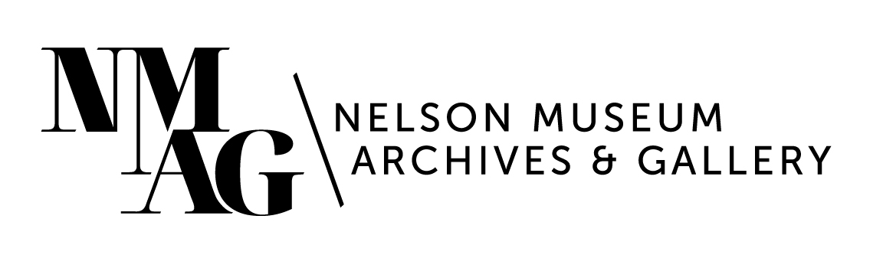

Press Release

Media contact:

Stephanie Delnea, Communications and Development Manager

Nelson Museum, Archives & Gallery

communications@nelsonmuseum.ca

250.352.9813 x. 204

For immediate release

*Up-and-coming on the NY art scene, local artist Amelia Ford returns for first exhibition at the Nelson Museum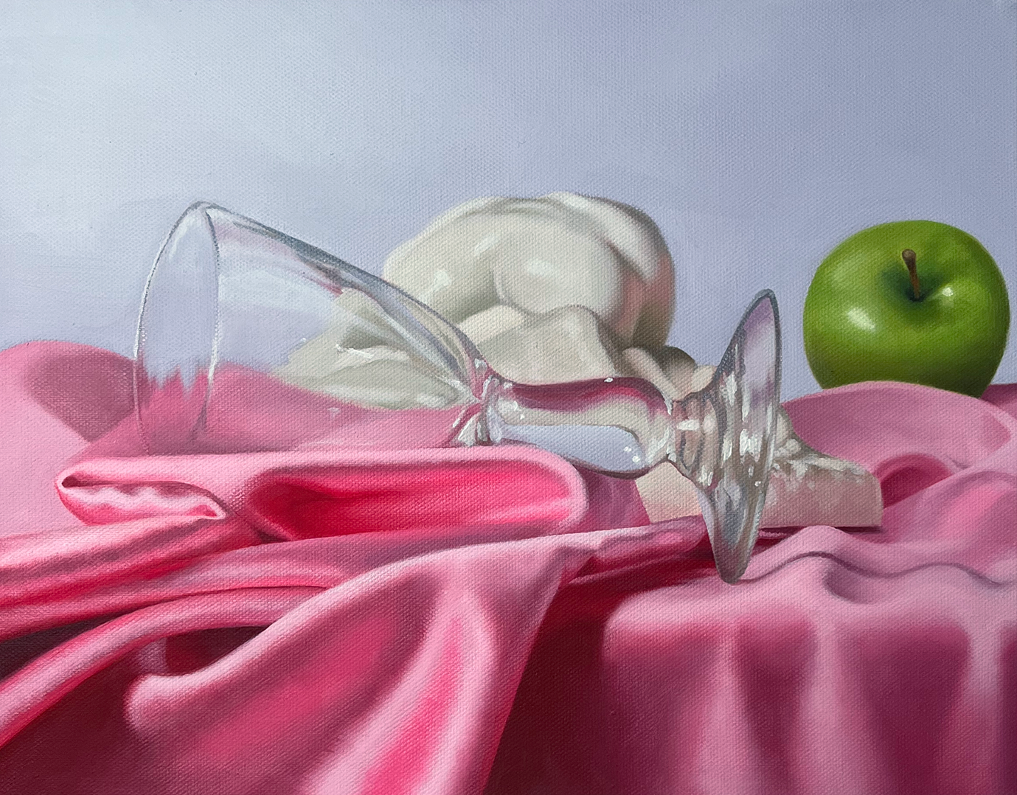*

Nelson, BC (January 27, 2025) - Before breaking the rules, you must first understand them. Emerging artist Amelia Ford works within the confines of the traditional still life painting tradition–masterfully manipulating oils to capture the shine of an apple, or the folds of bright silk, or light through broken glass–but it's in the composition of her subjects, rather than the items themselves, where the deeper meaning lies.

Finding inspiration in the works of Vanessa Bell, Ethel Sands, Gluck, and Berthe Morisot–female impressionists who share her interest in challenging the traditional style, Ford uses many of the same objects but foregoes the dusty symbology of death and religion and replaces them with modern themes of femininity, sexualization, and dehumanization.

Amelia Ford, *Paperweight Danaid,* oil on canvas, 2024.

The female form is a common thread between Ford’s current study in still life and her earlier work. Pieces such as “*Embrace*” (2022) feature unsettling images of both man-made and natural female bodies, highlighting how women are often treated as objects. She uses materials like plastic and human skin to explore the idea of women being seen as part-human, part-object, where it's hard to tell what's real and what's artificial.

“How is sustainable social equity possible without the acknowledgement of unsustainable objects? I view these objects as evidence of inequality, and the evidence exists among us, with us, and for us,” writes Ford in an artist statement for the 2022 group show *The Assembly // Sustainability* at the Alternator Gallery in Kelowna. “I present this evidence as a blow-up doll, both environmentally and socially unsustainable, a fake plastic body is humanized to dehumanize us.”

Examples of both distinct periods in Ford’s emerging career will be on display in *Vessels*, which opens Friday, February 14 at the Nelson Museum, Archives & Gallery. Ford will be in attendance at the opening and will also be participating in events at the Nelson Museum in the weeks following. *Vessels* runs February 15 to May 24 in Gallery B.

“There is confidence and opulence in the lines and colour on display,” says Nelson Museum Curator Arin Fay. “Amelia brings a mature style to her work. The themes and critical inquiry that are carried through the works are not imposed but emerge, revelling in colour and shadow and questioning the world in which we live.”

Born and raised in Nelson, Ford graduated from LV Rogers Secondary in 2018 and completed her Bachelor of fine Arts at the University of British Columbia Okanagan in 2022. She has participated in exhibitions throughout the Southern Interior as well as in New York, where she currently lives and works, and is pursuing her Master of Fine Arts degree.

For more information about the exhibitions and events at the Nelson Museum, visit nelsonmuseum.ca.

-30-