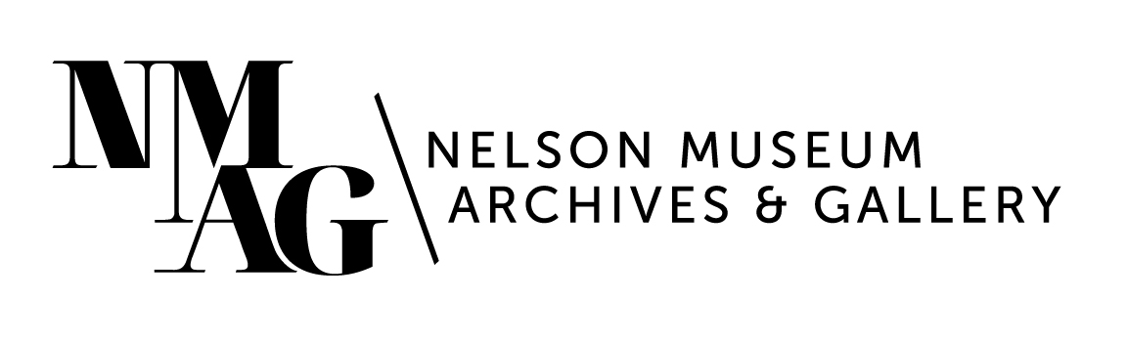

Press Release

Media contact:

Stephanie Delnea, Communications and Development Manager

Nelson Museum, Archives & Gallery

communications@nelsonmuseum.ca

250.352.9813 x. 204

For immediate release

*Create and connect with free artist trading card maker space sessions at the Nelson Museum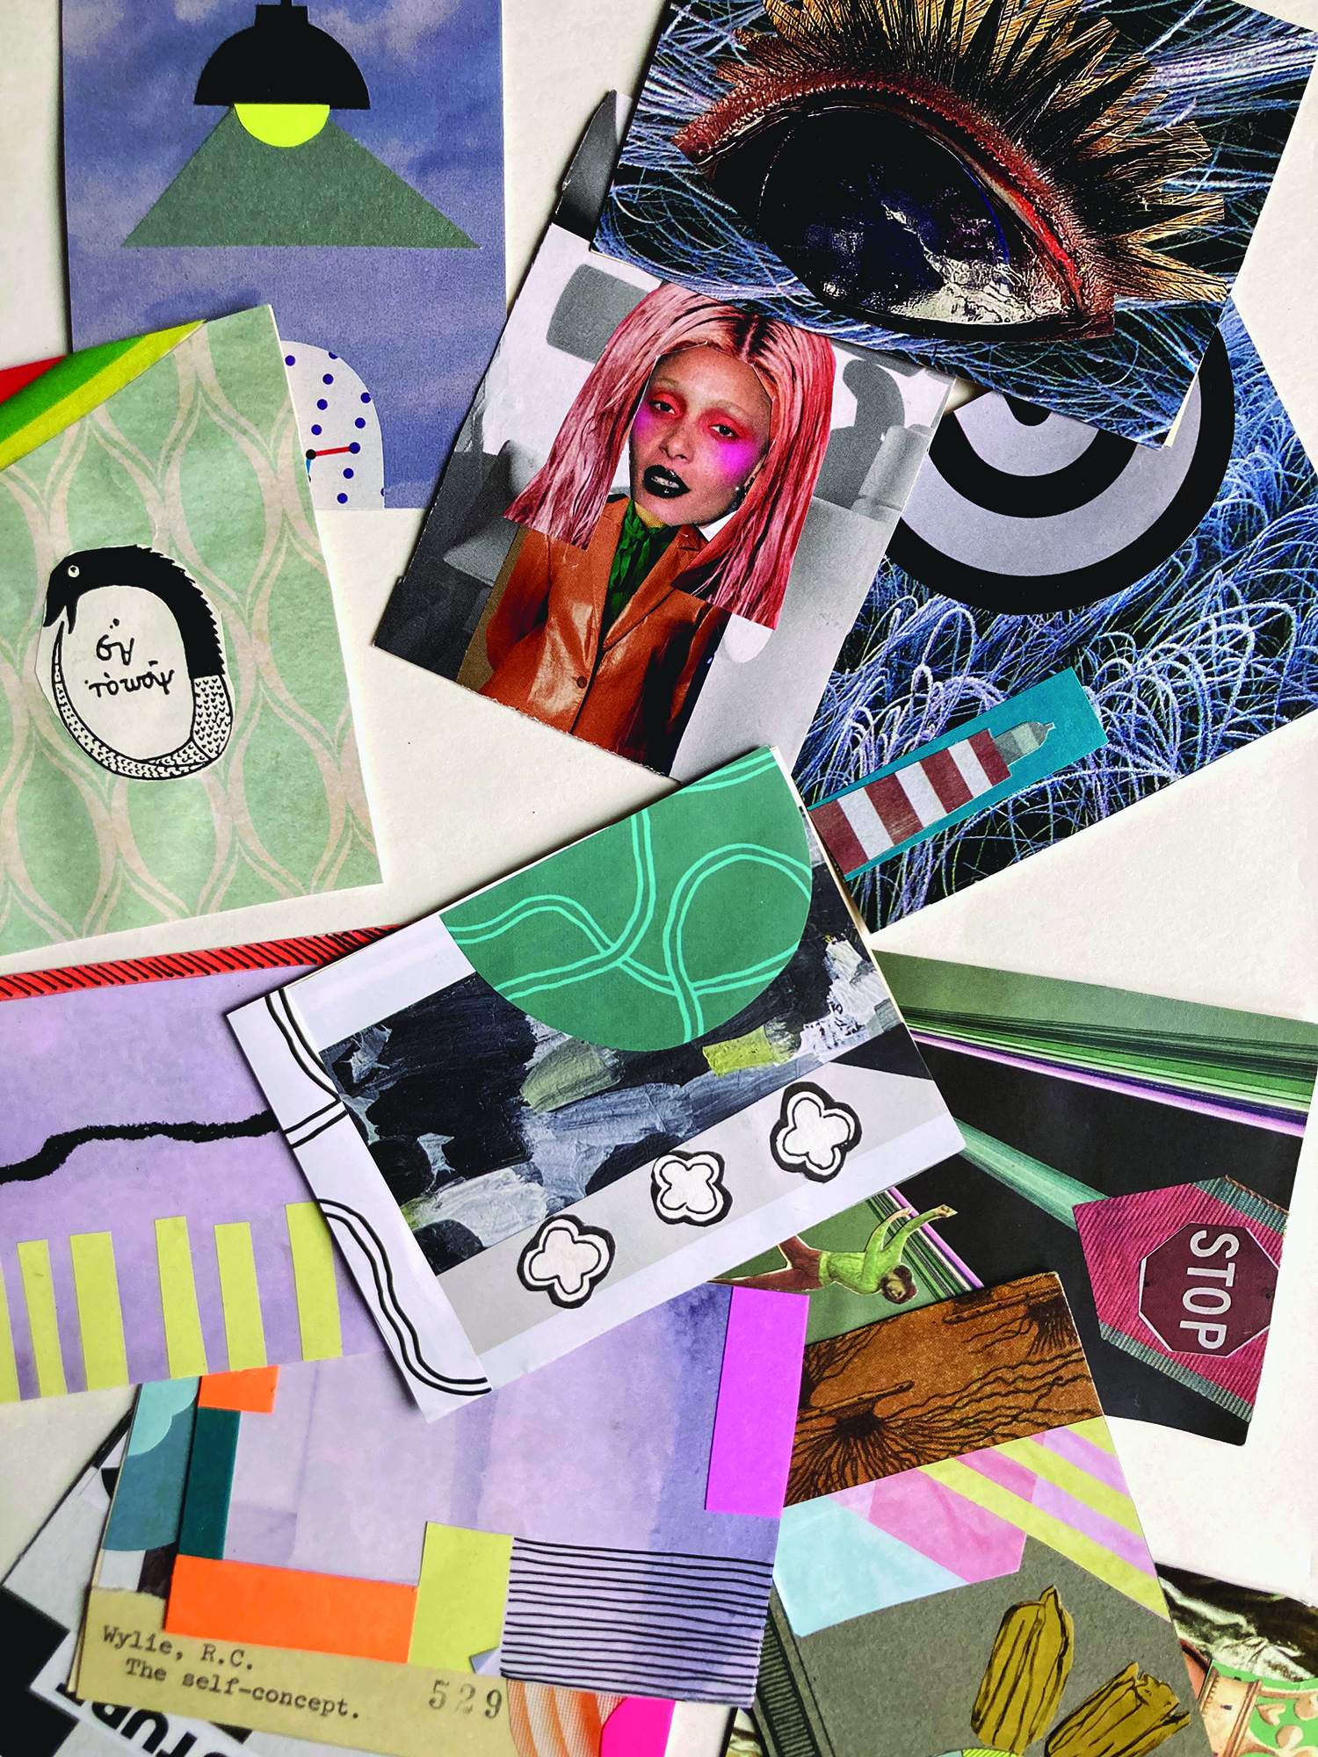*

Nelson, BC (January 6, 2025) - Artists and creators of all ages and skill levels are invited to create and trade art cards with the Nelson Museum in 2025. Artist trading cards (ATCs) are an accessible way for everyone to participate in artistic experimentation, creativity and community building rather than consumption.

Artist trading cards are tiny works of art created with the intention of trading or giving away; they are the size of a hockey card and can be made from any variety of materials and mediums. Popularized in the late 90s by Swiss artist M. Vänçi Stirnemann, and first appearing in Canada by Kootenay artist Don Mabie, the ATC movement has grown to encompass exhibitions and trading sessions in over 30 countries around the world. In recent years, Mabie’s work was included in the group exhibition *WORD* (2019) at the Nelson Museum, alongside Canadian artists Nicole Dextras, Graham Gilmore, Joi Arcand, Shane Koyczan, and K.C. Hall.

*A sample of artist trading cards. People of all ages are invited to drop-in to the maker spaces offered at the Nelson Museum. Photo by Kalika Bowlby.*

“Artist Trading Cards provide a fun way to try new mediums and materials, explore creative ideas and build community,” says Kalika Bowlby, Nelson Museum Education Coordinator and maker space host. “These monthly maker spaces are a safe, inclusive, playful opportunity for connection and creativity.”

ATC maker spaces are being held on the last Thursday of every month – January 30, February 27, and March 27 – from 4-6pm at the Nelson Museum (502 Vernon Street). These are free drop-in maker spaces for all ages and no registration is required. Participants are welcome to attend one, some, or all of the sessions, and are encouraged to trade their creations.

For more information about events and programs at the Nelson Museum, visit nelsonmuseum.ca.

-30-