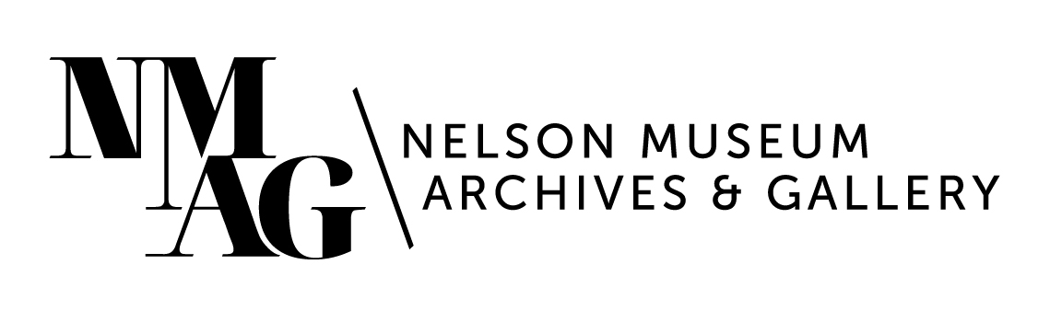

Press Release

Media contact:

Stephanie Delnea, Communications and Development Manager

Nelson Museum, Archives & Gallery

communications@nelsonmuseum.ca

250.352.9813 x. 204

For immediate release

*Louis Riel Day commemorated with the West Kootenay Métis Society and the Nelson Museum, Archives & Gallery*

Nelson, BC (November 7, 2024) - Louis Riel, a Métis leader who championed Indigenous and Métis rights in Canada—once viewed by many as a rebel—is widely recognized as a significant figure in Canadian history, and his contributions to Métis identity and rights have been increasingly acknowledged.

On Saturday, November 16 from 11am to 2pm, the Nelson Museum, Archives & Gallery, in partnership with the West Kootenay Métis Society, is commemorating Louis Riel Day with a series of free events. At 11am, the Métis flag will be hoisted at Nelson’s City Hall, followed by the official launch of the Truth and Reconciliation case in the Museum’s 2nd floor local history exhibit. Following the launch, a meal of stew and bannock will be served in the breezeway outside the Museum entrance.

The Truth and Reconciliation case tells a complex story about the opening of the southern regions of British Columbia, the displacement of First Nations and Métis people in this region, and the foundation of the Canadian residential school system. This complex story is told through several artifacts from the Nelson Museum collection, including the official uniform of Edgar Dewdney, Lieutenant Governor of BC from 1892 to 1897; a handwritten letter presented to Dewdney in 1886 from the students of the Dunbow Industrial School in High River, AB; and a collection of children’s shoes from a 2021 memorial to commemorate the discovery of unmarked graves at the Kamloops Indian Residential School, that were donated to the museum from the West Kootenay Métis Society in 2021.

“The addition of the Truth and Reconciliation Case signifies the first time that the word ‘Métis’ has been included in the local history museum space – until now, Métis people were referred to as voyageurs, if at all,” says Social Justice Lead Lesley Garlow. “Sharing the story of Louis Riel alongside that of Edgar Dewdney is a strong example of how we can add complexity and understanding to history, without overwriting the existing content.”

As part of the launch of the display case, the museum will also be screening the short documentary *Otipemisiwak: The People Who Own Themselves*, which was produced in 2021 alongside the gallery exhibition of the same name. West Kootenay Métis Society past president Don Courson will also say a few words.

The Truth and Reconciliation case is the latest to be updated in the museum space, following the lacrosse case in 2021 and the addition of Jaime Black’s *The REDRESS Project* in 2022. Additional small-scale updates are planned throughout the next few years while the exhibit redevelopment planning is underway.

For more information about events at the Nelson Museum, please visit nelsonmuseum.ca. For information about the West Kootenay Metis Society, please visit the WKMS Facebook page at <https://www.facebook.com/westkootenaymetis/>.

-30-