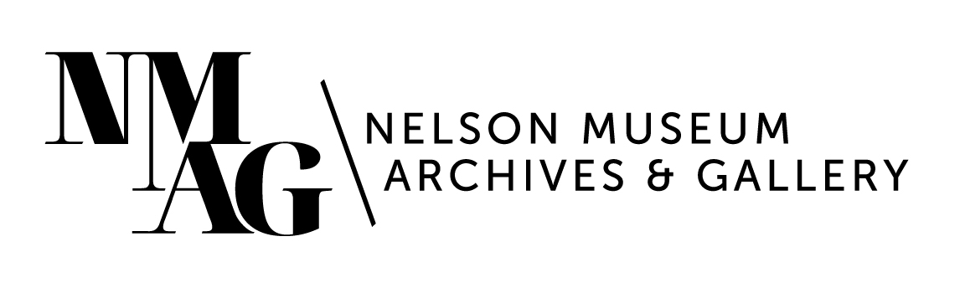

Press Release

Media contact:

Stephanie Delnea, Communications and Development Manager

Nelson Museum, Archives & Gallery

communications@nelsonmuseum.ca

250.352.9813 x. 204

For immediate release

*PULP* group exhibition explores the poetry within paper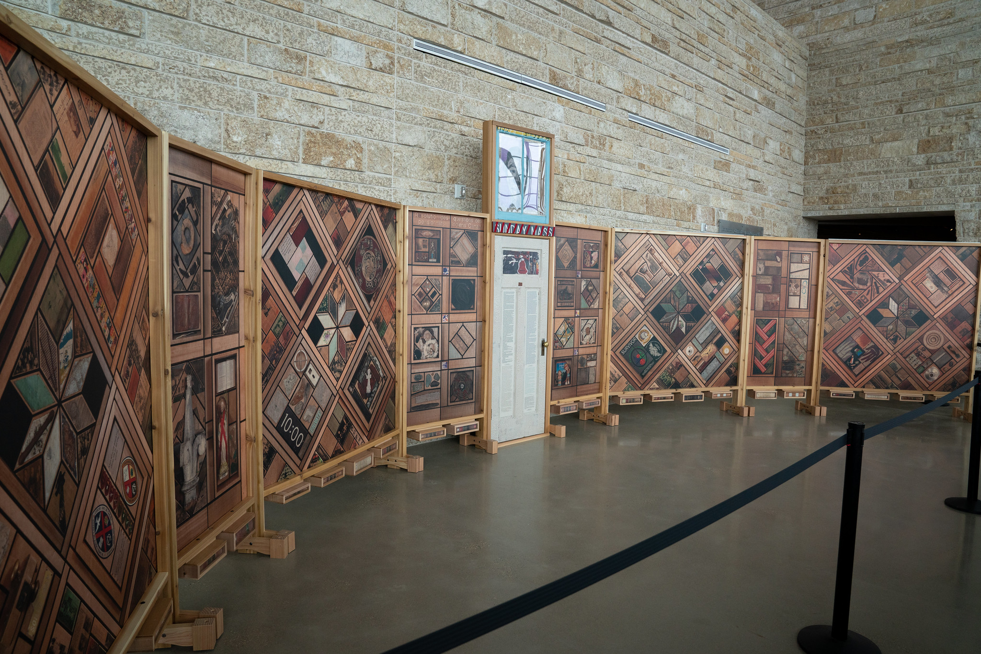

Nelson, BC (July 25, 2024) - Seemingly disconnected remnants of clothing, crumbling buildings, and fragmented cultures are woven together into a blanket, designed to shine light on the Indian Residential School system that connects them, and stand as a monument to the resiliency and strength of those who survived them.

The Nelson Museum, Archives & Gallery (NMAG) is honoured to exhibit a replicated portion of *The Witness Blanket*, on tour from the Canadian Museum of Human Rights in Winnipeg, Manitoba. Inspired by a woven blanket, *Witness Blanket* is a large-scale work of art created by master carver Carey Newman, containing hundreds of items reclaimed from residential schools, churches, government buildings, and traditional and cultural structures from across Canada.

*The Witness Blanket* travelling reproduction. Photo courtesy of the Canadian Museum of Human Rights, by Aaron Cohen.

"We find our way to the understanding and empathy of unimaginable things through the lived experience of artists and the history they represent and reflect,” says Nelson Museum Curator Arin Fay. “Carey Newman’s *Witness Blanket* illustrates the ongoing impacts of genocide through the tangible and representative fallout – children's shoes, door frames, language – it's an assemblage of past and present pieces that tell a story of unspeakable sadness, told through the beauty and hope of artistic expression.”

*The Witness Blanket* project offers visitors the opportunity to learn about the legacy of Canada's residential school system and Indigenous resiliency, and is a unique opportunity to discuss, understand, and experience complex issues through art.

*The Witness Blanket* will be exhibited in Gallery A from August 9 to September 20, 2024. There will be an opening ceremony on Friday, August 9 at 7pm, which is a free event and open to the public. Screenings of the *Witness Blanket* feature documentary will be booked throughout the duration of exhibit. Due to the limited run of the exhibition, additional times for school tours have been added. To book a tour for your class or school group please email [tours@nelsonmuseum.ca](mailto:tours@nelsonmuseum.ca).

The original artwork is permanently installed at the Canadian Museum of Human Rights after embarking on an extensive three-year tour of the country in 2013-14. Newman worked closely with the Museum to develop the travelling reproduction piece, which allows the stories and messages of the original Witness Blanket to continue to impact audiences across the country.

British Columbia artist Carey Newman, whose traditional name is Hayalthkin'geme, is Kwakwa̱ka̱’wakw from the Kukwaḵ̓a̱m, Gix̱sa̱m, and Wawałaba’yi clans of northern Vancouver Island, and Coast Salish from Xwchíyò:m (Cheam) of the Stó:lō S’olh Temexw (traditional territories) along the upper Fraser Valley. On his mother’s side of the family, his ancestors are English, Irish, and Scottish settlers. These cultural traditions and worldviews inform his artwork. He was first inspired to create *the Witness Blanket* by his father Victor’s experiences at residential school.

For more information about the exhibitions, programs, and events at the Nelson Museum, as well as screening times for *the Witness Blanket* documentary, please visit nelsonmuseum.ca.

-30-