Deaccessioned items
130-Object description: hand woven blanket 150 x 200 cm 60” x 80” warp yellow wool weft yellow wool with brown designs of geometric flowers woven as 2 panels stitched together, bound with machined and hand sewn satin binding in soft brown
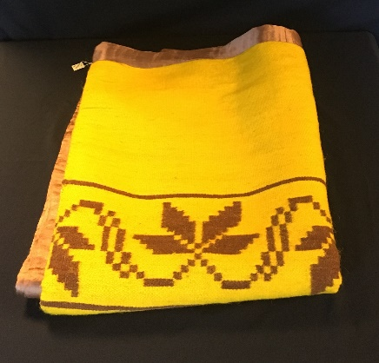

209- 61 ½” x 77’ handwoven cover white cotton warp white cotton and cream wool warp in variable stripes with 6 cm 2 ½” crocheted white cotton lace edging on 3 sides. 3 panels 52 cm 20 ½” 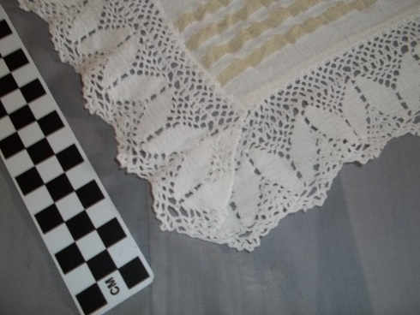 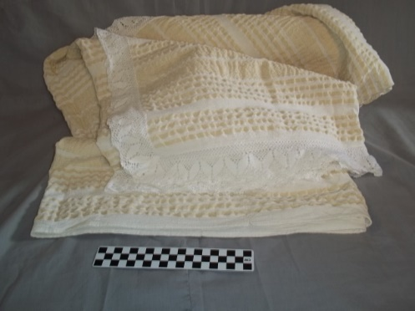

130-60 x 200 cm 62” x 80” rose velveteen cover with 18 cm 3” fringe, “carved” pattern of a leaf in nap of velveteen. Sturdy dark black underside.
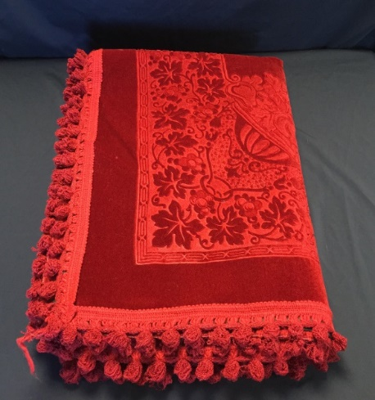
426-Blanket 76” by 60.5” Burnt orange and white cotton geometric pattern in triangular shapes with flower-shaped patterns within.
