Artifacts Available for Transfer
Accession # | Object Name | Description | Photo
1978.044.161 | Hand Towel | Plain white cotton hand towel. Visible stains and creases. | 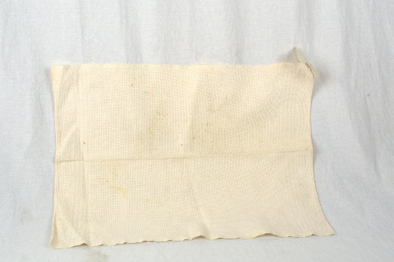
1979.079.013b | Doily | Round white doily with cotton centre and lacy crochet edges. | 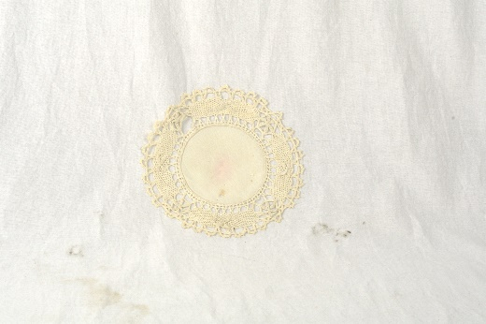
1979.079.014 | Doily | Doily with white cotton centre and crochet edges that form 6 points. | 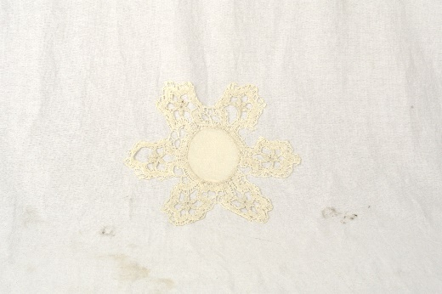
1979.079.021 | Doily | White circular crochet doily. | 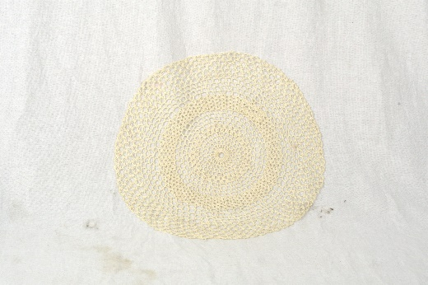
1979.079.032 | Table Runner | White/cream table runner. Assumed to be cotton. Staining throughout | 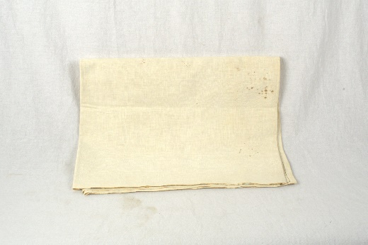
1982.002.007 | Doily | Round doily with 5 ¾” white damask centre and 2” ruffled crochet edges. Monogramed with initial H in centre. | 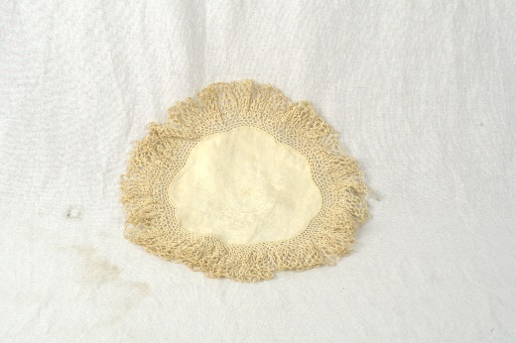
1982.002.008 | Doily | White doily with 5” octagonal damask centre. 2 ½” scalloped crochet edges. | 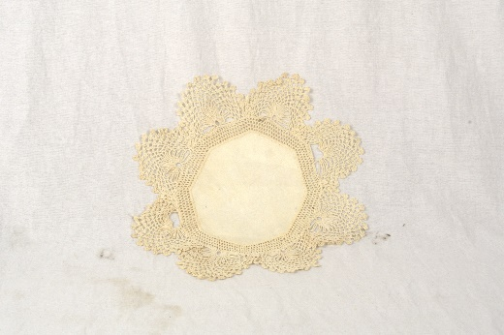
1983.001.065 | Hand Towel | White linen hand towel. Some light staining. | 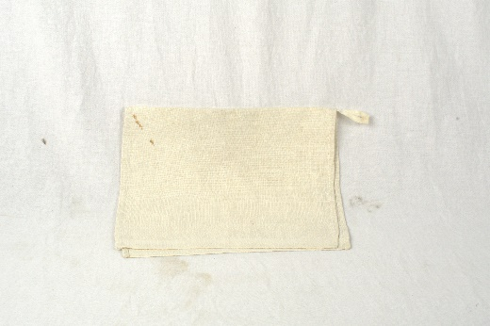
1983.027.037 | Pouch | Pouch with red affixed label. Label is only partially legible listing off wholesale locations in Canada. Contains 3 corks. | 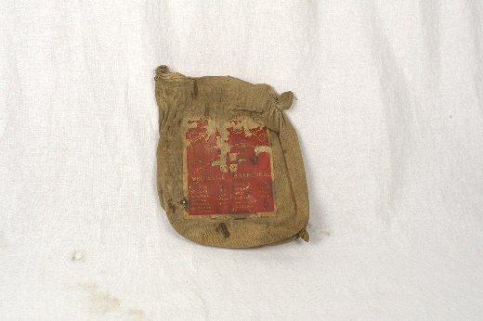
1983.027.043 | Pouch | Small cotton pouch with drawstring at the opening. | 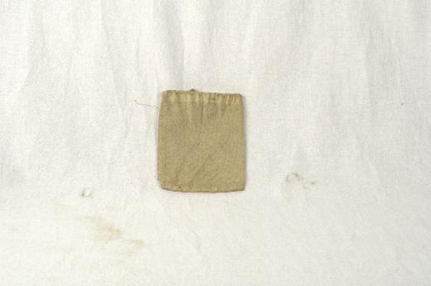
1991.002.060 | Hand Towel | Cream coloured hand towel with some stains. | 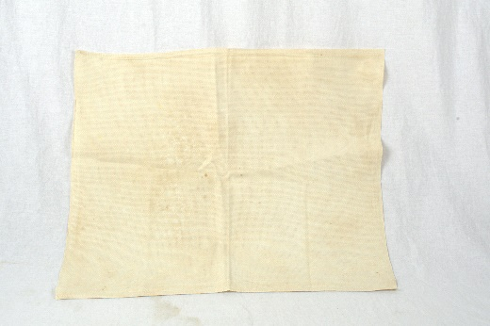
1995.005.001 | Pole Screen | Victorian era pole screen banner. Green with intricate beadwork. Fringe along the bottom and ropes with tassels attached at the top to hang. | 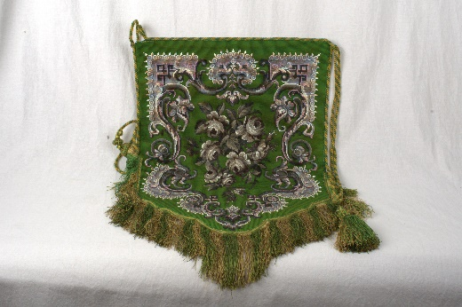
2007.023.001 | Bag | Flour sack. Ogilvie brand “Special-K” whole wheat flour. Cut down the side – now a flat sheet. | 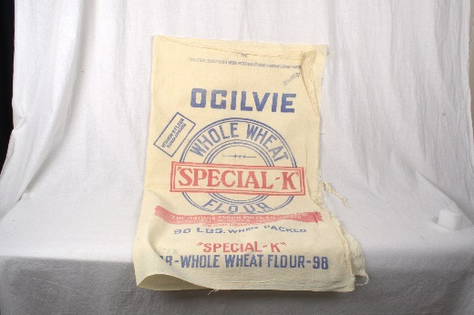
2007.023.002 | Bag | Sugar sack. St. Lawrence brand pre cane sugar. Cut down the side – now a flat sheet | 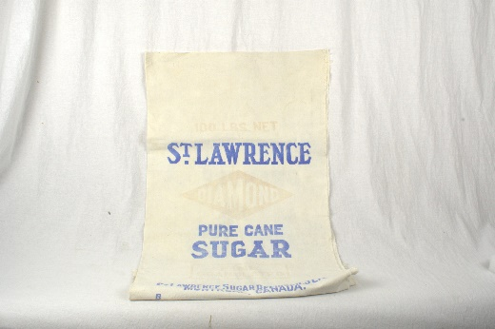
2007.023.004 | Bag | Fabric bag with four blue stripes and 4 orange/red stripes. Centre reads “Massabesic A” | 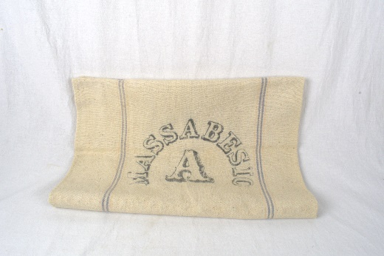
2011.021.001 | Blanket | Green and black plaid blanket with real fur lining. Edges are left unfinished and the blanket and lining are loosely stitched together. | 