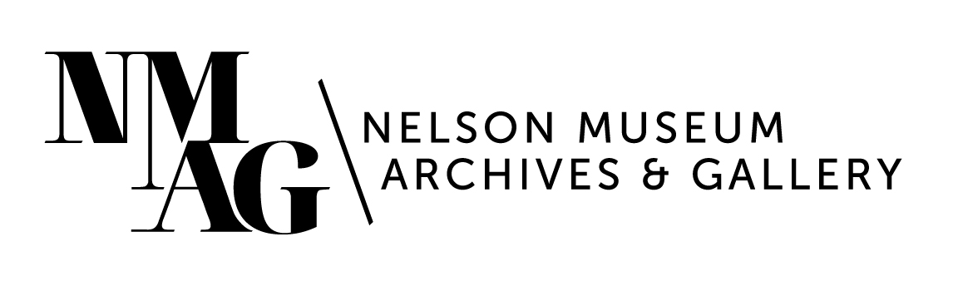
Press Release

Media contact:
Stephanie Delnea, Communications and Development Manager
Nelson Museum, Archives & Gallery
communications@nelsonmuseum.ca
250.352.9813 x. 204

For immediate release

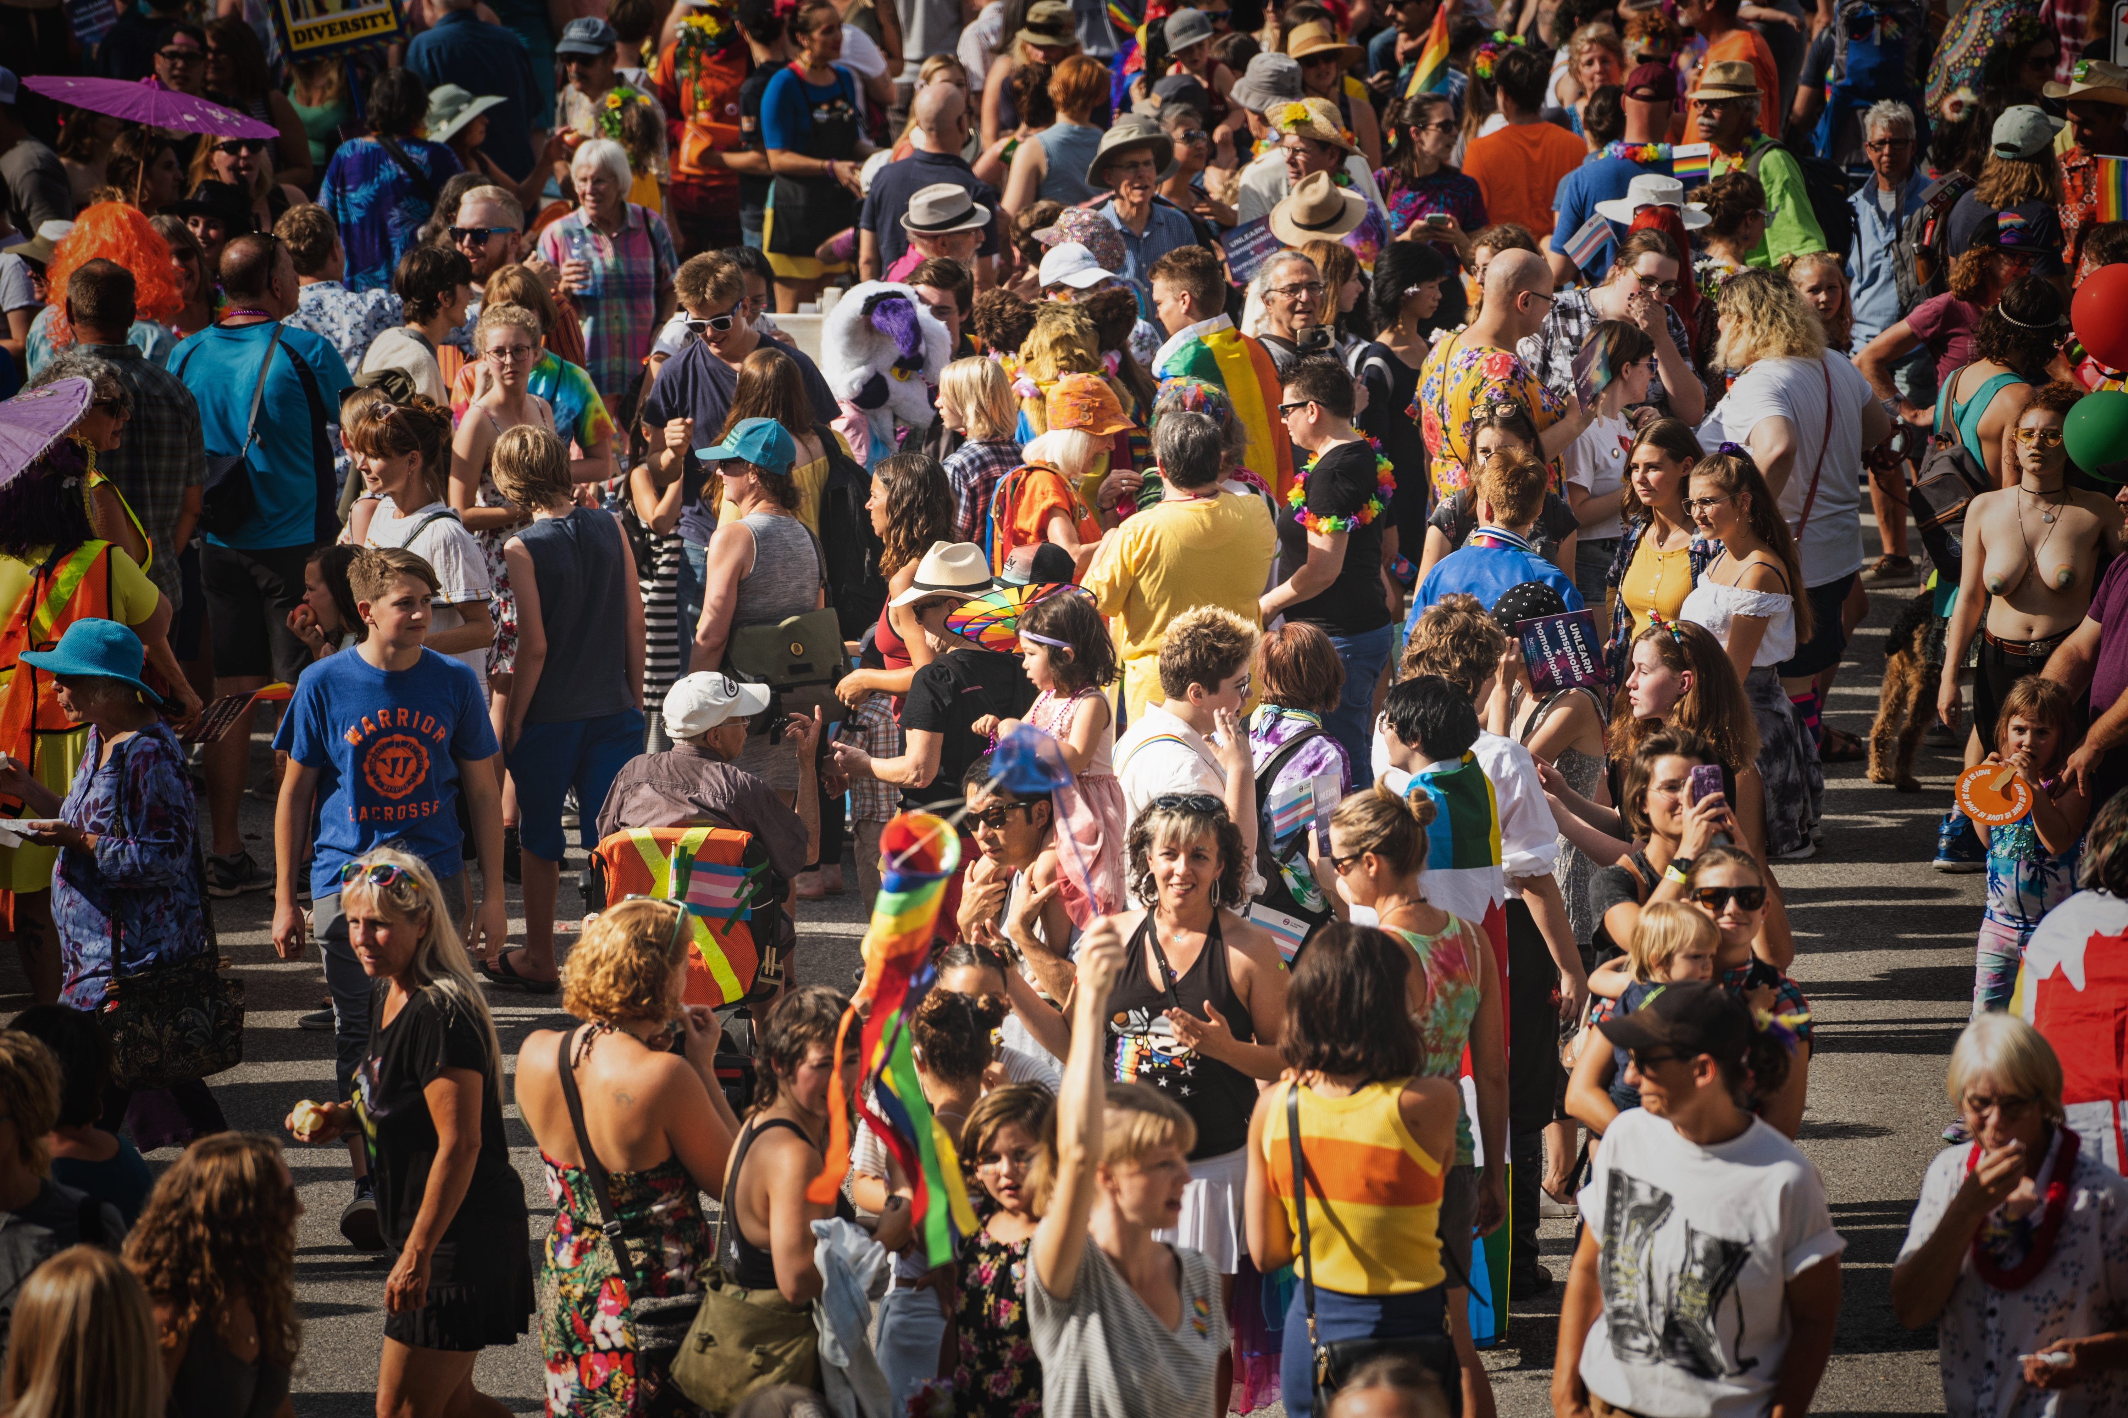
We Love a Parade! Nelson Museum opens permanent installation celebrating LGBTQ2S+ history in the Kootenays

Nelson, BC (June 7, 2024) - In the summer of 2021, the Nelson Museum launched the gallery exhibition Kootenay Pride: We Love a Parade! to celebrate the history of the West Kootenay Gays and Lesbians Society, which had been meticulously compiled by longtime Archives volunteer Michael Wicks. We Love a Parade! inspired the documentary film Queering the Interior, and a robust education program that is available for district educators.

Pride parade 2019. Photo by Jamie Srigley.

The Nelson Museum is officially launching a new permanent installation of We Love a Parade! featuring a localized timeline of events, images, and curatorial statements provided by Nelson Museum Curator Arin Fay, and Research Assistant Adrian Dunkerson. The launch takes place on Thursday, June 13 from 5-7pm at the Museum, and will feature a screening of the 10-minute trailer for Queering the Interior, as well as an introduction from the film’s director Amy Bohigian, a tour of the Queer Archives by Michael Wicks, and refreshments provided by Kootenay Kombucha, Sprout Plant-Based Eatery, L&C French Bakery, and the Kootenay Co-op. The event is free and open to the public.
“How we understand and remember the past can help us envision more inclusive futures,” says Nelson Museum Education Coordinator Kalika Bowlby. “Permanently including a local perspective on queer history and rights provides an opportunity to build awareness and empathy. At NMAG we are working to make everyone feel represented and share diverse perspectives of history.”
Thank you to Kootenay Kombucha, Sprout Plant-Based Eatery, L&C French Bakery, and the Kootenay Co-op, as well as the Columbia Basin Trust for supporting this event.
The Nelson Museum has also recently been accredited by the Rainbow Registered program – a national designation granted by Canada’s 2SLGBTQI+ Chamber of Commerce that signifies the Museum’s commitment to creating a safer, more welcoming, and inclusive space for the 2SLGBTQI+ community. NMAG joins over 300 businesses across the country and is proudly the first Rainbow Registered organization in the Kootenays.
To stay up to date on events, programs, and exhibitions at the Nelson Museum, visit nelsonmuseum.ca and sign up for the monthly newsletter.
To find out more about the Rainbow Registered program, visit rainbowregistered.ca.
-30-

