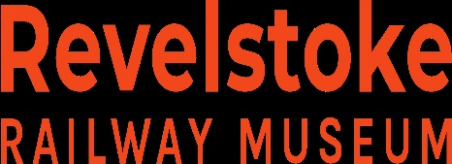
For Immediate release

June 5, 2024

5500 Pavilion Project – CPR SD40 Locomotive No. 5500

The Revelstoke Railway Museum is launching the 5500 Pavilion Project that will restore and conserve the significant CPR No. 5500. Built in 1966, by General Motors Diesel Division of London, Ontario, the CPR No. 5500 was the first diesel-electric locomotive to usher in a new era of high-horsepower diesel locomotive technology and became a widely-recognized symbol across Canada.

No. 5500 has a two-stroke, 16 cylinders, turbocharged 3,000-horsepower diesel engine. The diesel prime mover drives a 600-volt electric generator which provides power to six electric traction motors. One on each axle. No. 5500 weights 390,000 lbs. or 177 metric tons, is 65 feet 8 inches or 20meters long and is 15 feet 5¼ inches or 4.7 meters high. As the very first of its kind in Canada, CPR No. 5500 is an important example of this once-common locomotive.

The CPR No. 5500 is the first locomotive to receive a Canadian Cultural Property Designation meaning the locomotive is declared as having great cultural and historical value. Certified Cultural Property are cultural artifacts that have been verified by the Canadian Cultural Property Export Review Board to be of “outstanding significance and national importance” to Canada.

This summer, the Revelstoke Railway Museum will physically move CPR No. 5500 to a more prominent location on the museum grounds and build a specially designed conservation and exhibition space. The 5500 Pavilion will protect the artifact from weather deterioration and will provide space for future restoration and conservation work as well as offer a popular cultural attraction.

The Revelstoke Railway Museum, opened in 1993, it is known as one of Canada’s best railway museums, playing a valuable role in collecting, preserving and interpreting Canada’s mountain railway stories. Its collection exceeds 6,500 three-dimensional artifacts, 7,500 archival objects, 13,000 photographs, and 17 locomotives and cars. The Museum’s website is www.railwaymuseum.com.

For more information, please contact Scott Marsden, Executive Director, Revelstoke Railway Museum at 250-837-6060 or director.railway@telus.net

