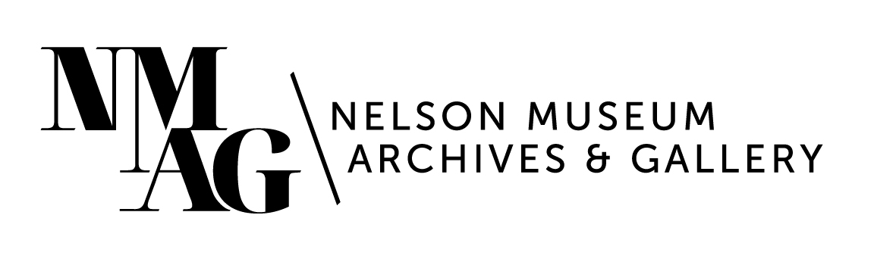
Press Release

Media contact:
Stephanie Delnea, Communications and Development Manager
Nelson Museum, Archives & Gallery
communications@nelsonmuseum.ca
250.352.9813 x. 204

For immediate release

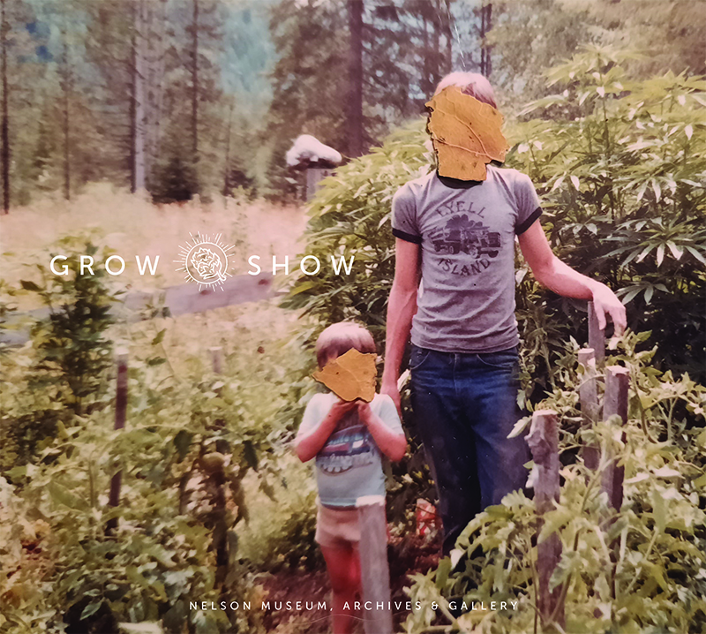
Grow Show book launch: Celebrate 4/20 at the Nelson Museum

Nelson, BC (April 9, 2024) - Shakespeare (may have) smoked it. Bill Clinton definitely smoked it, but didn’t inhale. The Kootenays grew it - a lot of it. And now the Nelson Museum has published a book about it.

Grow Show, a beautiful 144-page coffee table book filled with installation images, archival photos, and commissioned artwork, was inspired by the 2021 award-winning exhibition of the same name. It explores cannabis culture in the Kootenays through many different lenses including agriculture, economy, culture, politics, and community perspectives. Grow Show is the first collection of its kind - telling the story from the perspective of growers, smokers, advocates, dissenters, and enforcers. Many of the stories in Grow Show have never been shared publicly; together they chronicle an underground economy that built a small rural town in the BC Interior into the birthplace of legendary BC Bud.

Grow Show book cover, published by the Nelson Museum, Archives & Gallery.

Join MC Adam O. Thomas and Curator Arin Fay for an evening of storytelling at the official launch of Grow Show on Saturday, April 20 from 7-9pm. Some very special guest storytellers will be taking the stage to discuss the legends and lore of the cannabis industry. The event is free and refreshments will be served.
For more information about events and programs at the Nelson Museum, please visit nelsonmuseum.ca
-30-

