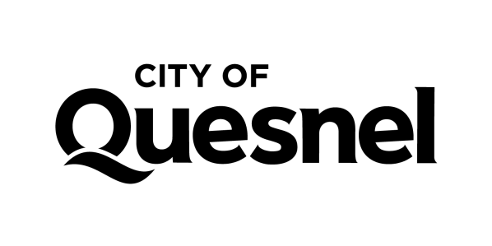

JOB POSTING
External - CUPE Local 1050

Position: Education & Outreach Coordinator, Quesnel Museum - Summer Student position | Status: Full-Time (Term 16 Weeks)**
Posting Date: March 22, 2024 | Application Deadline: April 18, 2024 by 4pm
Competition number: 24-33 | Wage: $19.50 (plus $1.20 in lieu of benefits)
How to apply:
Please send your resume with competition number, in confidence to:
Human Resources Advisor
City of Quesnel,
410 Kinchant Street,
Quesnel, BC V2J 7J5
Apply online or Email: hr@quesnel.ca (Word or pdf document only please)

The City of Quesnel wishes to fill a student position for an Outreach Coordinator at the Quesnel & District Museum & Archives. Reporting to the Museum & Heritage Manager, the Outreach Assistant will help with daily operations, including visitor reception and gift shop sales, security and maintenance. Additional tasks include:

- Assist with booked education programs
- Plan and implement outreach activities for community events and for the Museum
Steps Out program (free activities offered in LeBourdais Park 4 X for 1 hour)
- Monitor Social Media and prepare material for Instagram and Facebook
- Prepare scavenger hunts and hands-on activities for museum exhibits

The Quesnel & District Museum & Archives is a respected community organization known for its outstanding collection, engaging exhibits and high-quality programs and services. You will be joining a team of two permanent staff, two summer students and dedicated volunteers who help preserve the history of the North Cariboo and promote an appreciation of the region’s heritage. The position is suitable for a student with an interest in teaching, marketing or media studies.

Duration of work: May 14 to August 31, 2024 **
Hours/week: 37.5 Hours per week

REQUIRED QUALIFICATIONS

Education and Experience:

Applicants must be:
- A Canadian citizen or legally entitled to work in Canada.
- Willing to commit to the full employment period, with no other significant work commitments (more than 30 hours per week)
- 16-30 years of age, registered in, and returning to, full time education
- Approved as an eligible candidate by the Young Canada Works Program
- Must be in compliance with the City’s Mandatory Vaccination Policy

The ideal candidate:

- Enjoys meeting people & provides excellent customer service
- Has experience advertising through social media
- Has experience working with children - an awareness of the stages of learning development is an asset.
- Has superior written and spoken English language skills and is comfortable speaking & appearing on camera
- Is knowledgeable and interested in regional and British Columbia history
- Possess excellent organizational and computer skills
- Is self-motivated and able to work independently

Testing and interviews will be required.

The City of Quesnel is an equal opportunity employer. We celebrate diversity and are committed to creating an inclusive environment for all employees. We appreciate the interest of all applicants, but only those selected for an interview will be contacted.

** This position is subject to grant funding and the period of employment could be adjusted slightly to reflect funding and student schedules.

