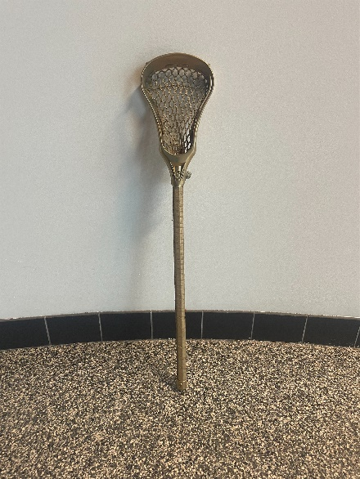
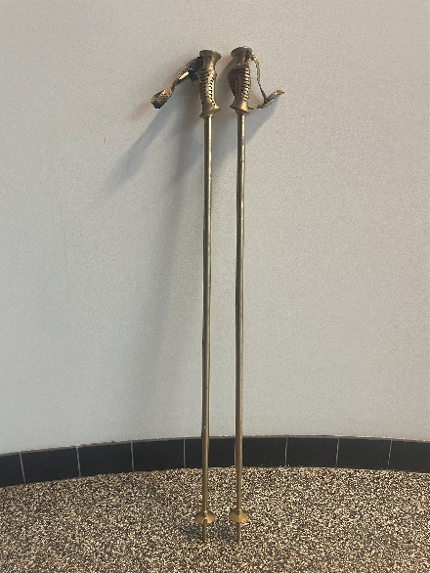
Gold painted sports equipment
Two ski poles
One lacrosse stick
One basketball, rugby ball, football
Pair of hockey skates
Pair of soccer cleats
Microphone with cord
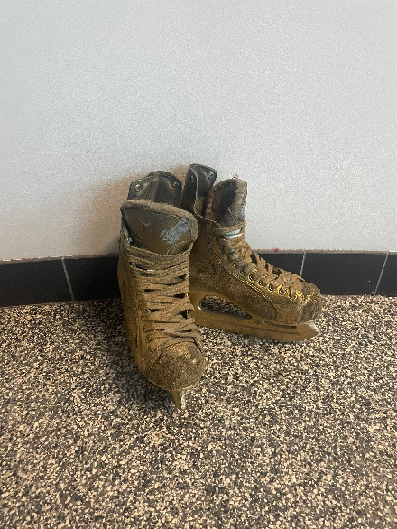
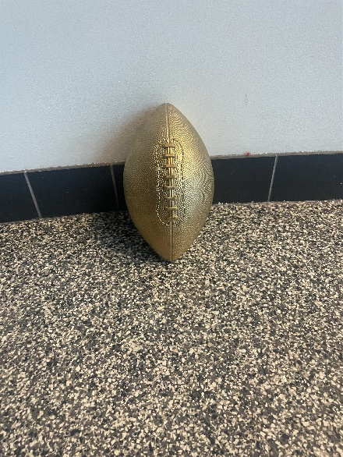
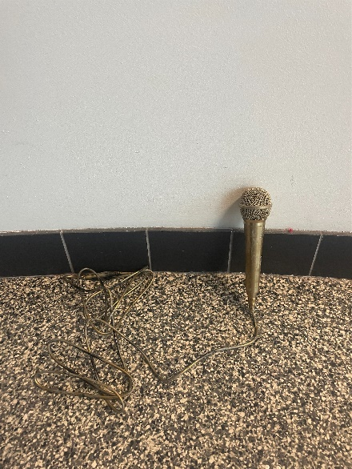
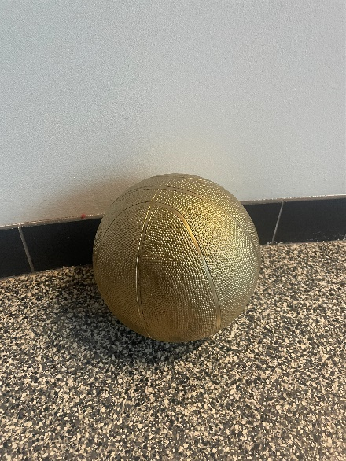
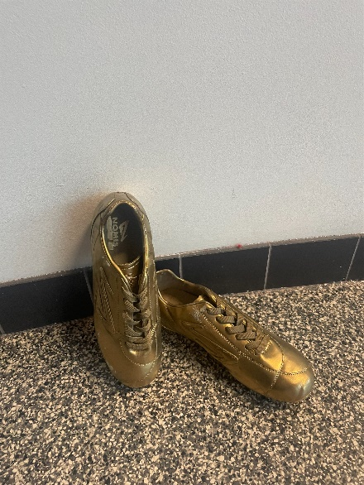
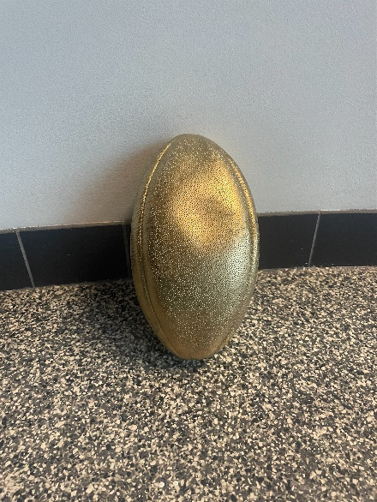

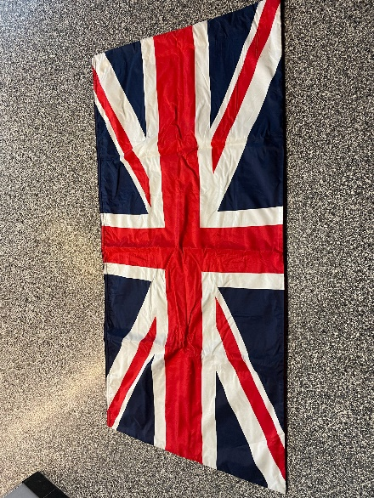

Union Jack flags
Back lined with velvet, 6 available
66” x 32”

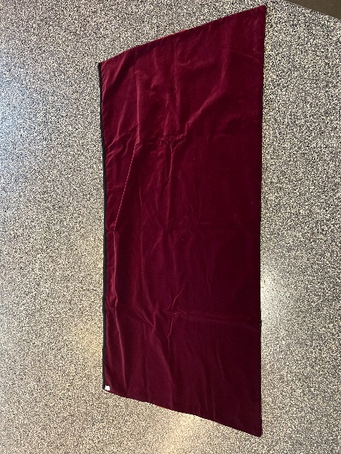

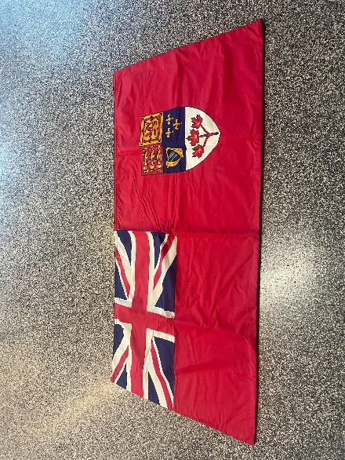

Canadian Red Ensign flags
Back lined with velvet, 6 available
66” x 32”

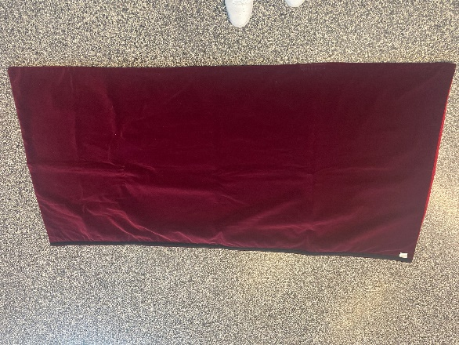

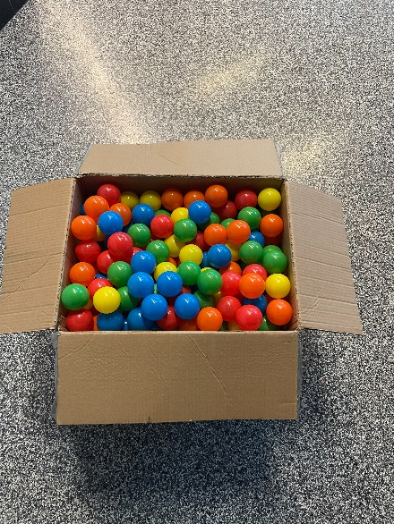

Box of colourful plastic balls, hollow

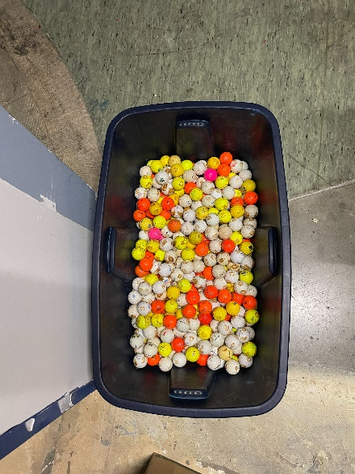

Box of colourful golf balls
Previously used as a display, golf balls have glue residue

Camera set up
Unused or lightly used, intended for taking photos of artifacts
Dolley not included
H: 46”
L: 23”
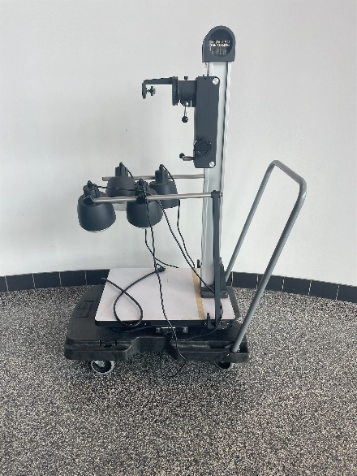
W: 19”

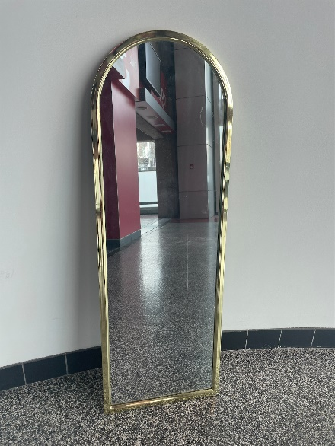
Standing mirror with gold trim
H: 50”
W: 17”

“Open” sign
Adjustable hours on the sign
Does not come with power adapter
H: 23”
W: 20”
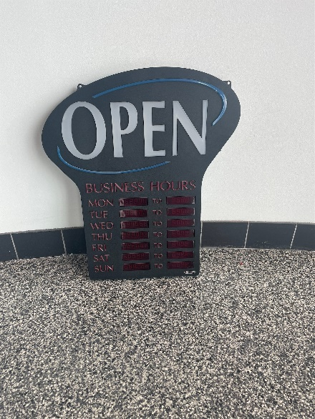

Plastic poster tube
D: 3”
H: 29”
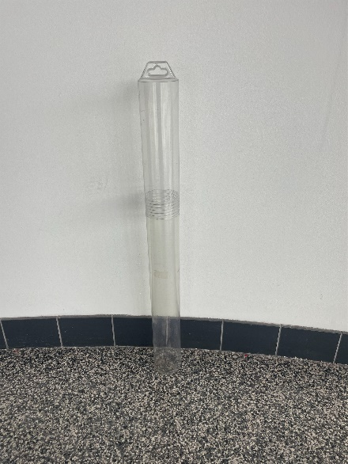

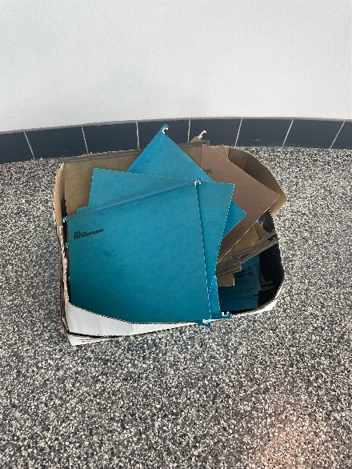

Box of miscellaneous folders
Most have hooks for filing

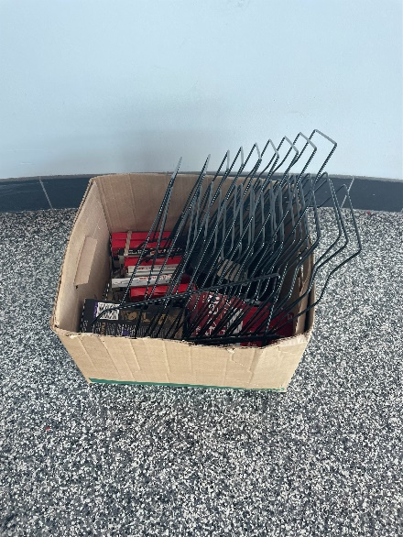
Box of miscellaneous office and AV supplies

