Deaccession List - Books

-In Training for Health: Malden Health Series, 1935

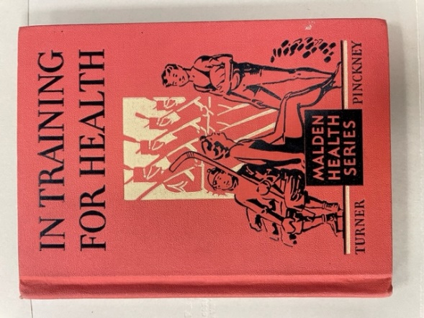

-The Joy Family: Malden Health Series, 1936

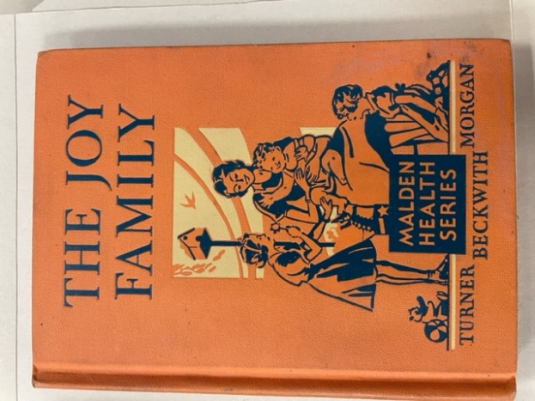

-Health Stories: Book One, undated (1930s)

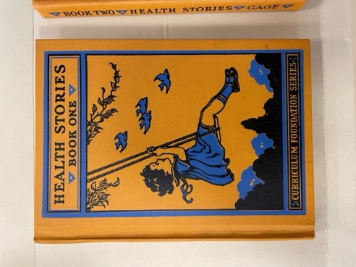

-Health Stories: Book Two, undated (1930s)

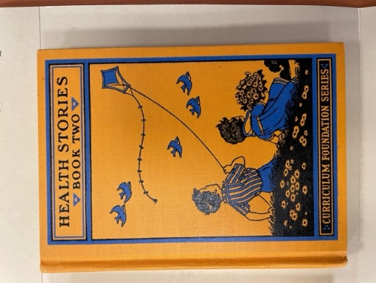

-Health Stories: Book Three, undated (1930s)

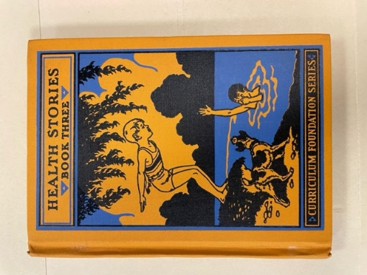

-Healthy Citizenship, undated

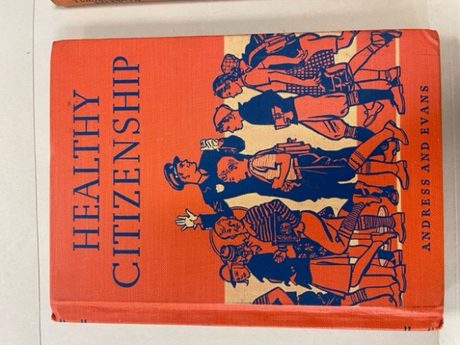

-The Beacon Study Readers: Book One, undated

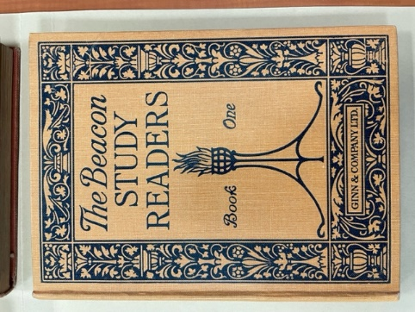

-The Beacon Study Readers: Book Three, undated

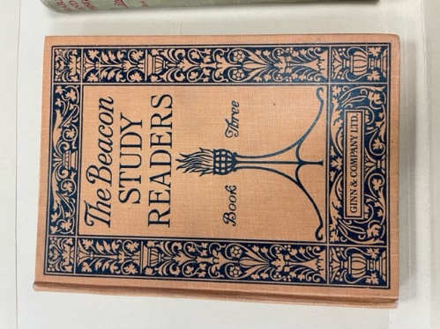

-Far Horizons: Bears and Things, 1938

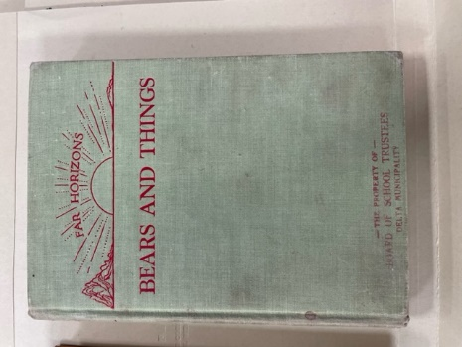

-The Silent Reading Hour: First Reader, 1923

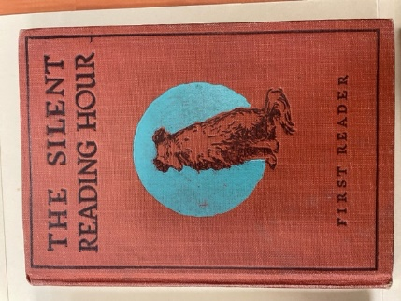

-The Silent Reading Hour: Third Reader, 1925

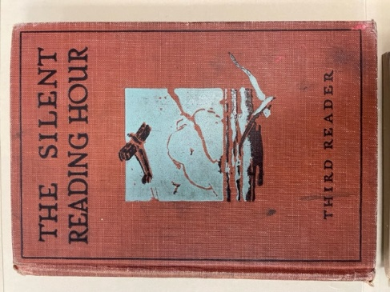

-Junior Arithmetic: Grade Three, 1941

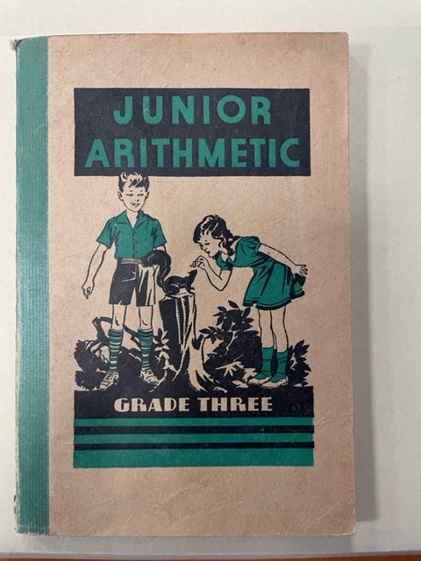

-Junior Arithmetic: Grade Five, 1941

