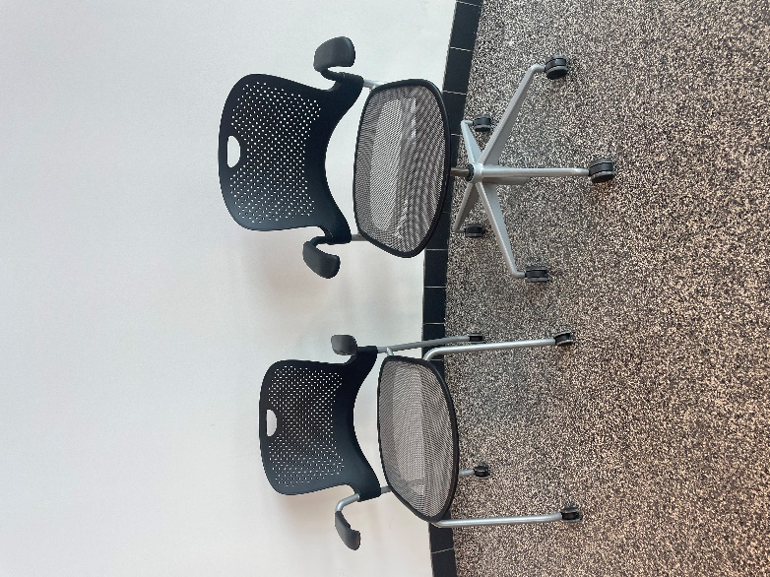
Both desk chairs are plastic and metal with armrests.
Chair on the right: Height: 32.5”
Width: 23.75”
Length: 24.5”
Chair on the left: Height: 38.5”
Feet diameter: 29”

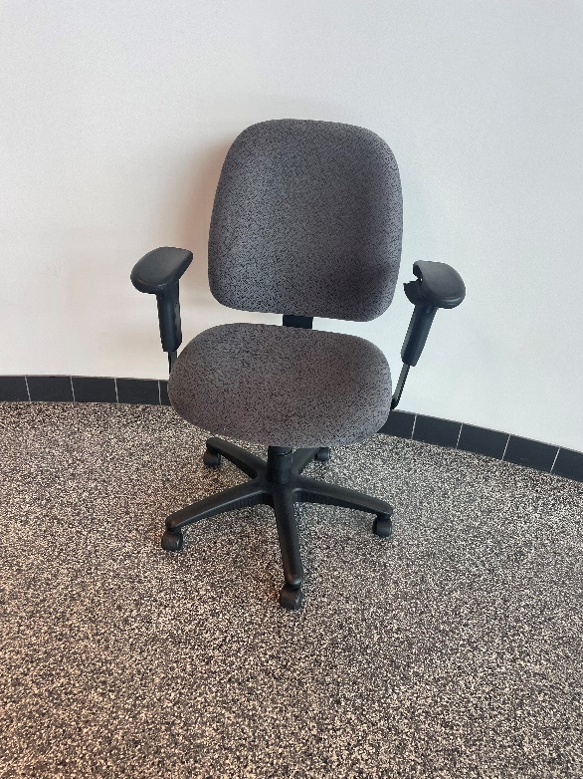

Plastic padded desk chair with armrests.
Dimensions: Height: 41”
Feet diameter: 26.5”

White circular table. The wheels pictured are a furniture dolly and not included.
Dimensions: Height: 29.5”
Diameter: 30”

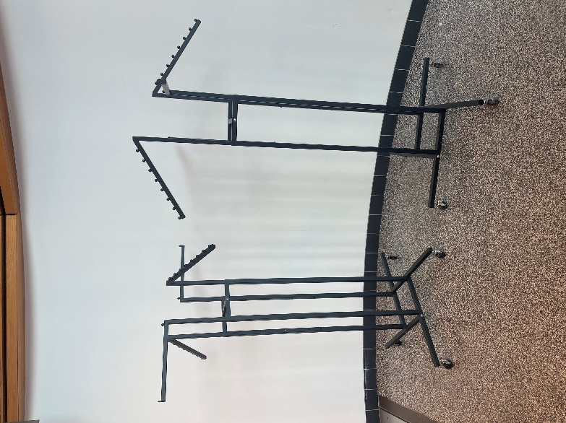
Black metal clothing racks. On wheels. Adjustable height.
Dimensions: Height: 55” – 75”
Length and width: 43”

White kiosks. Includes cable and plugs.
Dimensions: Height: 48”
Width: 40.5”
Length: 23”
Screen size: 42”

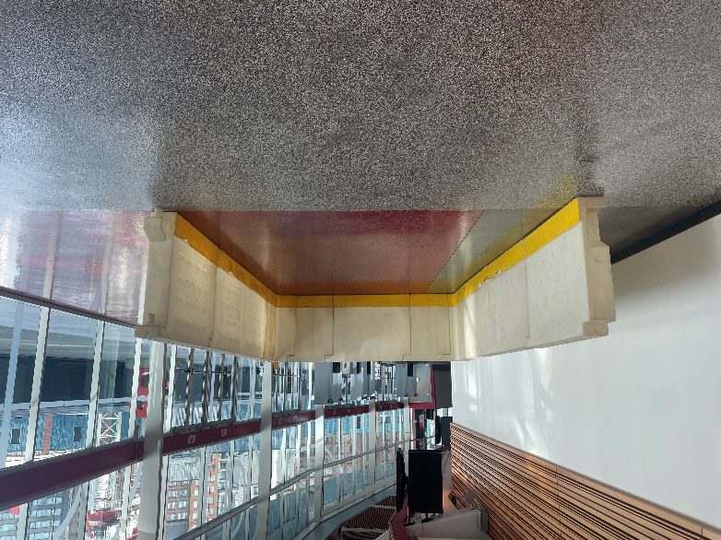
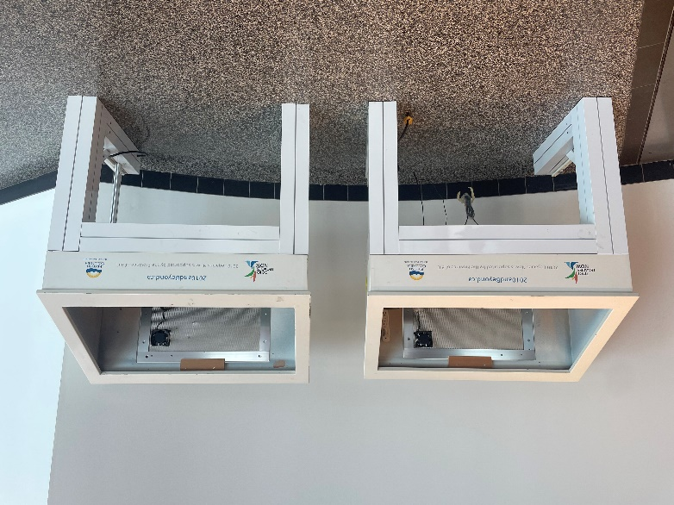
Hockey shootout rink. Half size of a smaller scale rink. Plastic. Currently dissassembled in 11 pieces. Comes with plastic “glass” and poles to complete the look.
Dimensions: Height: 42”
Length: 176” total, inside the rink is 168”
Width: 170” total, inside the rink is 88”
Board width: 8”

