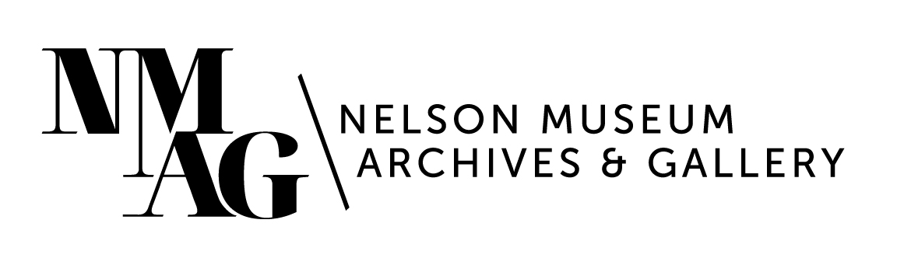
Press Release

Media contact:
Stephanie Delnea, Communications and Development Manager
Nelson Museum, Archives & Gallery
communications@nelsonmuseum.ca
250.352.9813 x. 204

For immediate release

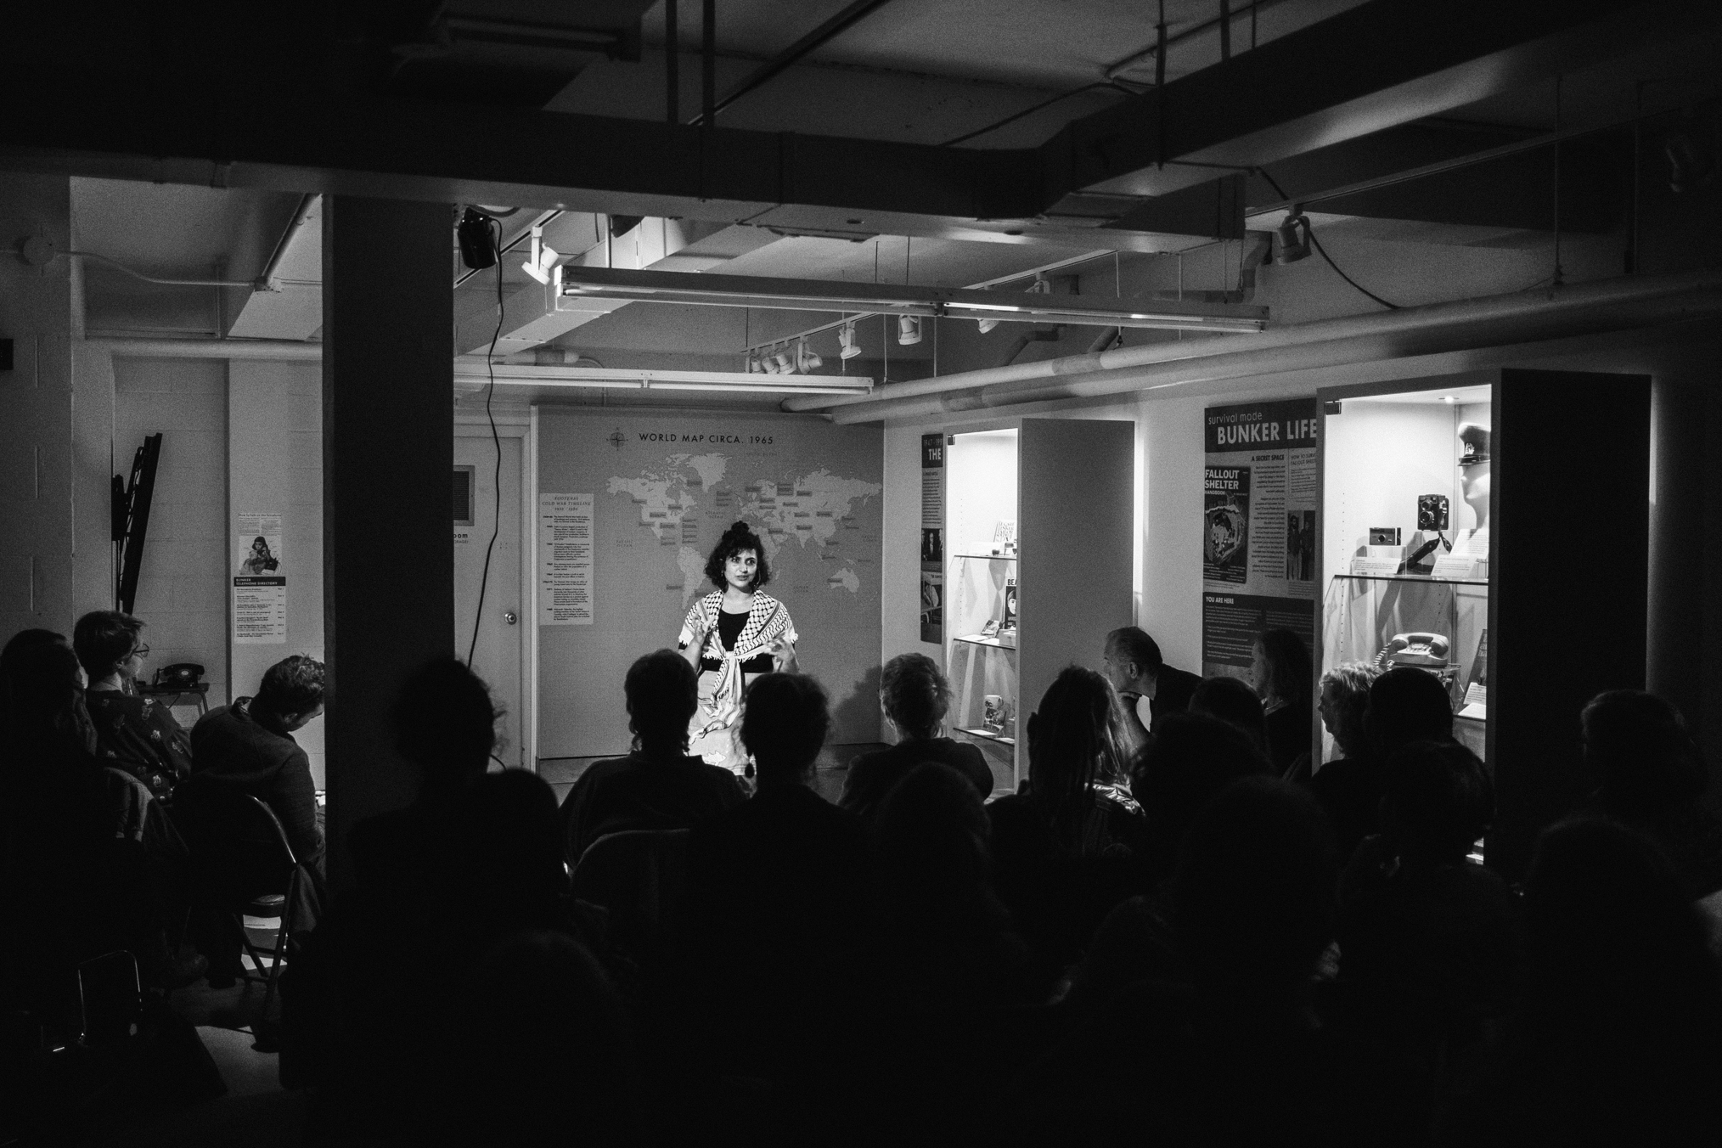
Are You Listening? returns for two more performances in the Bunker

Nelson, BC (October 23, 2023) - “Zaynab opens her heart and soul to you,” observed Meg Stewart, who was in the audience for the first performance of Zaynab Mohammed’s one-woman show Are You Listening? in the Cold War Bunker. “Her vulnerability allows you to reach into your own.”

The Nelson Museum, Archives & Gallery and the Nelson & District Arts Council are presenting two additional performances of Are You Listening?, on November 2 and 3; the first two shows, held Saturday, October 14, were sold out.

Zaynab Mohammed performing Are You Listening? in the Cold War Bunker on Saturday, October 14. Photo credit Louis Bockner

Are You Listening? is the story of a woman reflecting on what she has learned by leaning on the art of listening to herself, to others, and to the earth. It is the story of a young woman who loses her innocence at a young age due to cultural inequity, and how she finds freedom from centuries of colonization and displacement, Mohammed explains.

“Zaynab's beautiful and very personal poetry and performance was profound and deeply moving,” says Monica Carpendale, Executive Director of the Kutenai Art Therapy Institute, who also saw the first performance. “She manages an extraordinary balance between anger, pain and the desire for joy. Hearing personal stories is one of the best ways to antidote the depersonalization of war and atrocities.

“It is a brave and courageous performance,” Carpendale adds.

Mohammed will be performing Are You Listening? On Thursday, November 2 at 7pm and Friday, November 3 at 4pm. Both performances will again take place in the Cold War Bunker and will be followed by a Q+A session with the audience. Tickets are available at the Nelson Museum Front Desk or online at Eventbrite.

“The Bunker is a unique space with a complicated history, and it really amplifies the themes of inequity and displacement that are featured in Are You Listening?,” says Astrid Heyerdahl, Executive Director at the Nelson Museum, Archives & Gallery. “When the space was built in the early 60s, the intention was to house a small group of people that were almost exclusively white men. It is important that after 50 years we can amplify the voice of an incredible artist such as Zaynab in this space.”

Are You Listening? is co-presented by the Nelson Museum and the Nelson & District Arts Council, with support from the Columbia Kootenay Cultural Alliance and the Columbia Basin Trust.

-30-

