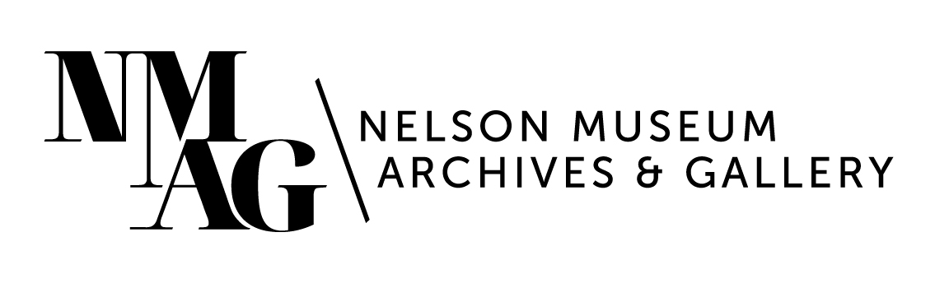
Press Release

Media contact:
Stephanie Delnea, Communications and Development Manager
Nelson Museum, Archives & Gallery
communications@nelsonmuseum.ca
250.352.9813 x. 204

For immediate release

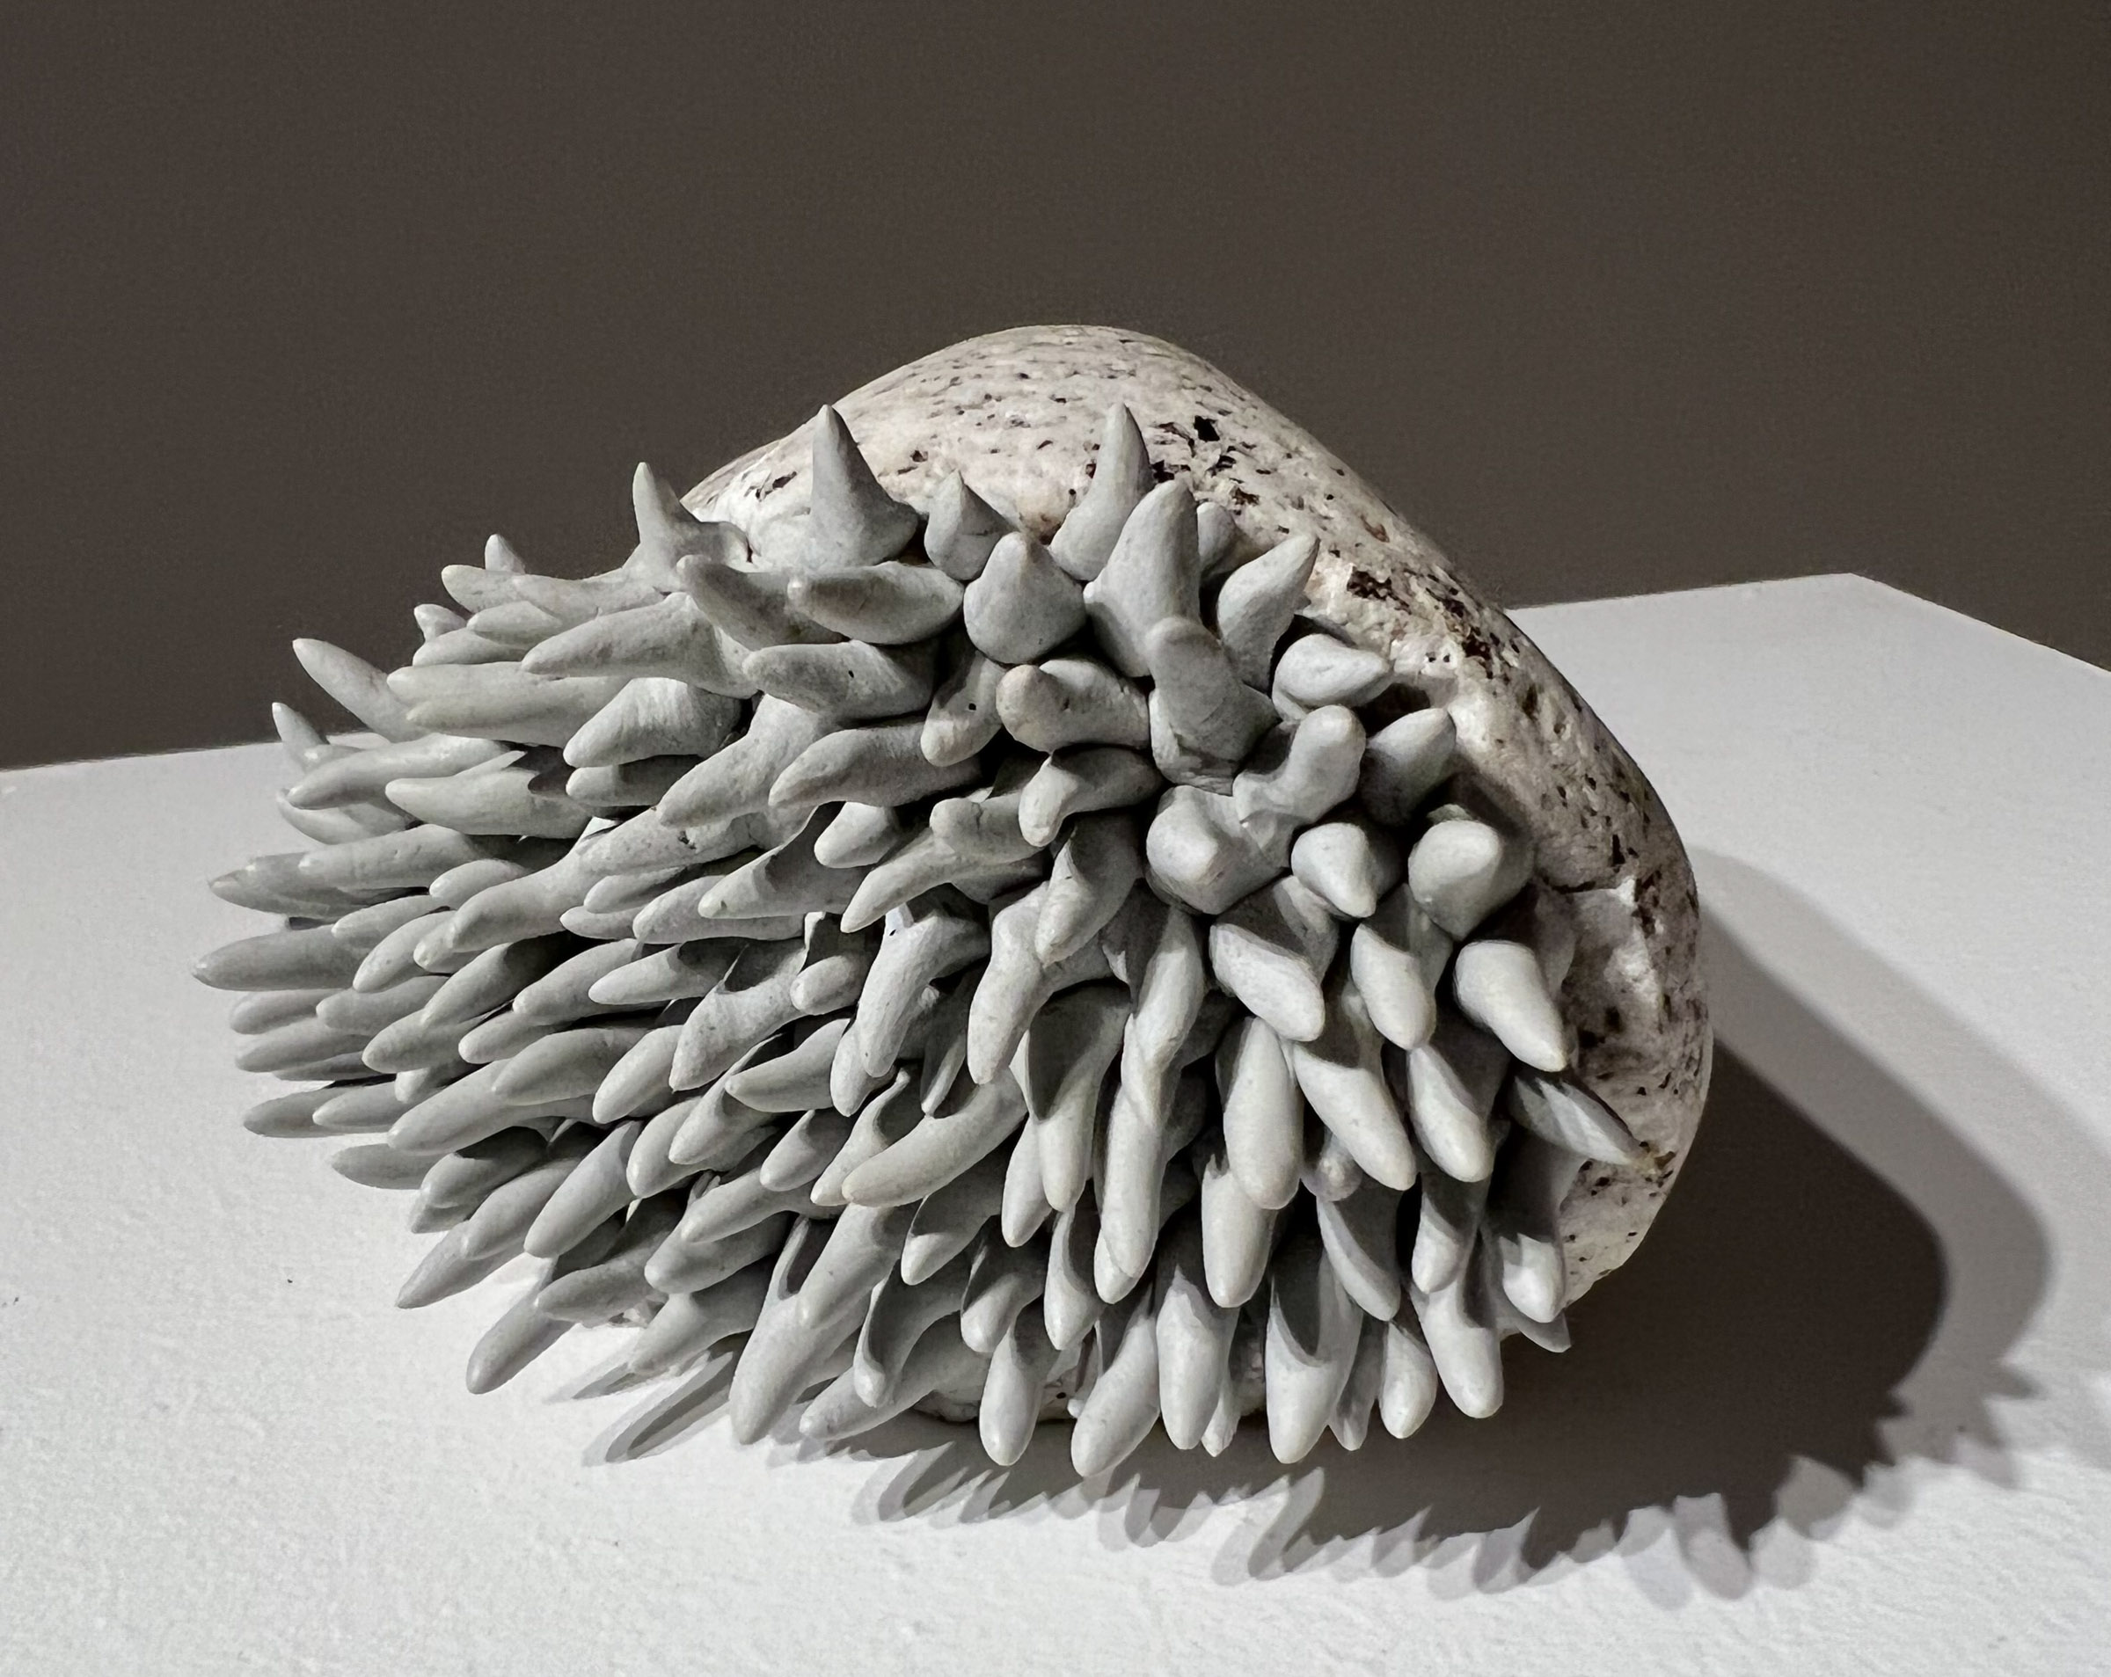
Give or Take a Few Million Years explores the art of the earth

Nelson, BC (October 12, 2023) - “In retrospect, I feel like my work as a geologist was, in fact, my art education.”

Nelson artist Carol Wallace reflects on her experience with the ridgelines and landscapes that have informed her life in Give or Take a Few Million Years, her upcoming exhibition at the Nelson Museum, Archives & Gallery, which opens on Friday, November 17 at 7pm and runs through February 2024. Through drawings, sculptures, and textiles she builds a dreamlike, otherworldly exhibition worth delving into.

Biomorphic Forms - apoxie sculpt on fractured rock. Photo: Carol Wallace

“Geology is like time travel. Rocks are visible evidence of earlier worlds going back more than 4 billion years,” Wallace says. “Atmospheres were created, oceans opened and closed, mountains were formed and eroded, and microorganisms evolved to a world we know today. We are all embedded in deep time.”

The exhibition invites the viewer to experience a visual anthology of stories found in the rocks. Geologic imagery is stitched and inked on layers of silk organza, magnified minerals of local bedrock are projected onto the gallery wall, biomorphic shapes are sculpted onto fractured rock, and ink drawings remind us that a rock is much more than its exterior surface.

“Give or Take a Few Million Years is an exhibition which brings together several distinct but interconnected series that Carol has developed over several years - a brilliant confluence of art and science, that challenges our collective understanding of time and evolution,” says Nelson Museum Curator Arin Fay. “The importance of presenting other perspectives is fundamental to understanding and expanding all subject matter, and seeing issues and ideas with open eyes not burdened by normative or limiting preconceptions. This exhibition presents a portal to a geological timescale rarely considered by people outside of the realm of science, and one which helps to tell the foundational story of place.”

Wallace’s career as an artist began with a bachelor's degree in Geology, which led her to exploring Northern BC, the Yukon and the Canadian Arctic. Her detailed field notes turned into geologic maps used by government agencies and led to Wallace starting a consulting company in Nelson. In 2014, Wallace decided to pursue her art career full time, and has since exhibited her work at galleries throughout the BC interior.

For more information about the events and programs at the Nelson Museum, please visit nelsonmuseum.ca

-30-

