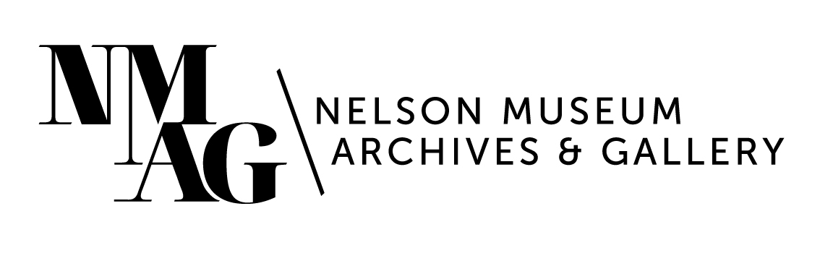

Press Release

Media contact:

Stephanie Delnea, Communications Coordinator

Nelson Museum, Archives & Gallery

communications@nelsonmuseum.ca

250.352.9813 x. 204

For immediate release

*Brain Scans / Neurotransmitting* turns a diagnosis into art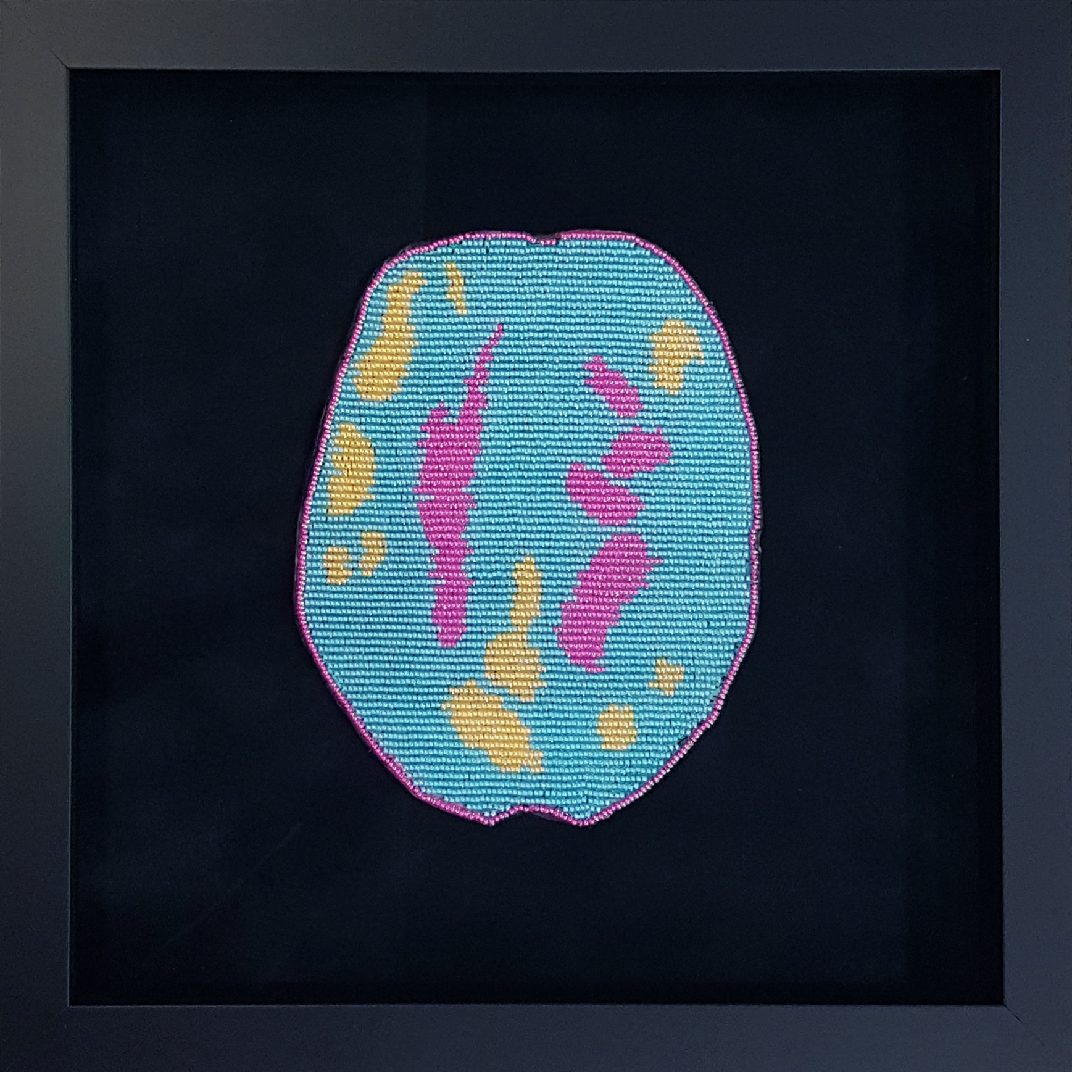

Nelson, BC (May 16, 2023) - One in five Canadians - about 7.6 million people - will struggle with mental health before age 25, according to the Canadian Mental Health Association, and only 25 per cent of children and teens have access to treatment, for a variety of reasons that range from socio-economic status to location to parental consent. Ruth and Theo Cuthand’s exhibition *Brain Scans / Neurotransmitting*, opening at the Nelson Museum on Friday, June 23, seeks to explore the difficulty of facing mental health challenges, and how families unite in support of one another.

“Mental health is a big problem on reserves and there’s a lot of shame with it,” says Ruth, whose contribution to the exhibition is a series of intricately beaded reproductions of MRI scans. They illuminate the brain scans of people with ADHD, depression, PTSD, and more. (There are also some pieces from an earlier series that focus on diseases such as measles and monkeypox.) “Mental health problems run in my family, so I’m really aware of it and want to being awareness to the fact that mental health is not something to be ashamed of.”

Ruth Cuthand, *ADHD*, RCH82, 2022, Glass beads, thread, backing, 11 1/4" x 11 1/4"

Ruth’s son Theo created a short film to accompany the beadwork, capturing a conversation about his latest manic episode. The film is presented from the perspective of a mother trying to care for an adult child as they experience mental illness, as well as the individual experiencing illness firsthand.

“As children and youth in our community experience a rising level of mental illness and anxiety, *Brain Scans / Neurotransmitting* provides visitors a gateway to begin an important conversation,” says Museum Curator Arin Fay. “The exhibition also speaks to the incredible power of art as a method of exploring and processing difficult circumstances.”

The show dovetails with *Otanimm/Onnimm* - a short film exhibition running concurrently in Gallery B – by Terrance Houle and his daughter Neko Wong-Houle, which shares the themes of family and kinship.

*Brain Scans / Neurotransmitting* opens Friday, June 23 at 7pm in Gallery A, and runs through October 21, 2023. School tours are available throughout the fall and can be booked via the Museum website at nelsonmuseum.ca/school-tours.

If you or someone you love is experiencing a mental health crisis, seek advice from a medical health professional. Local resources include Nelson Community Services (1-800-661-2121), Interior Health (250-505-7248), The Circle of Indigenous Nations (COINS) (250-231-4968), and Freedom Quest (250-505-9804). Additional information is available at 8-1-1 and the Canadian Mental Health Association ([https://cmha.bc.ca](https://cmha.bc.ca/)).

-30-