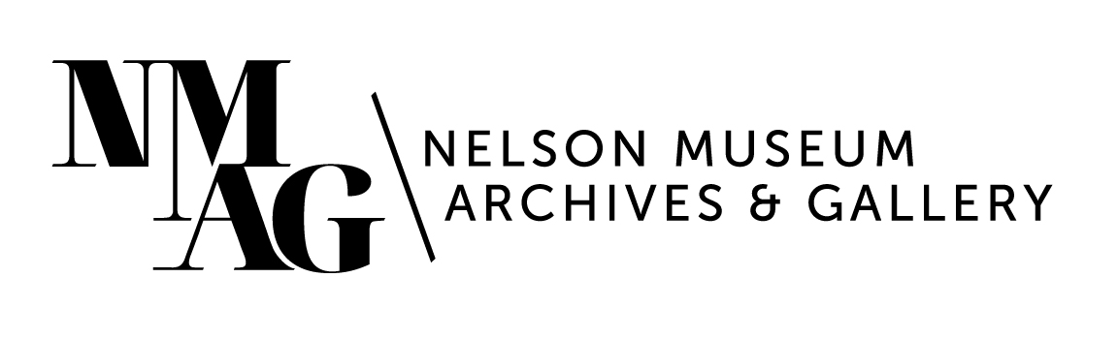
Press Release

Media contact:
Stephanie Delnea, Communications Coordinator
Nelson Museum, Archives & Gallery
communications@nelsonmuseum.ca
250.352.9813 x. 204

For immediate release

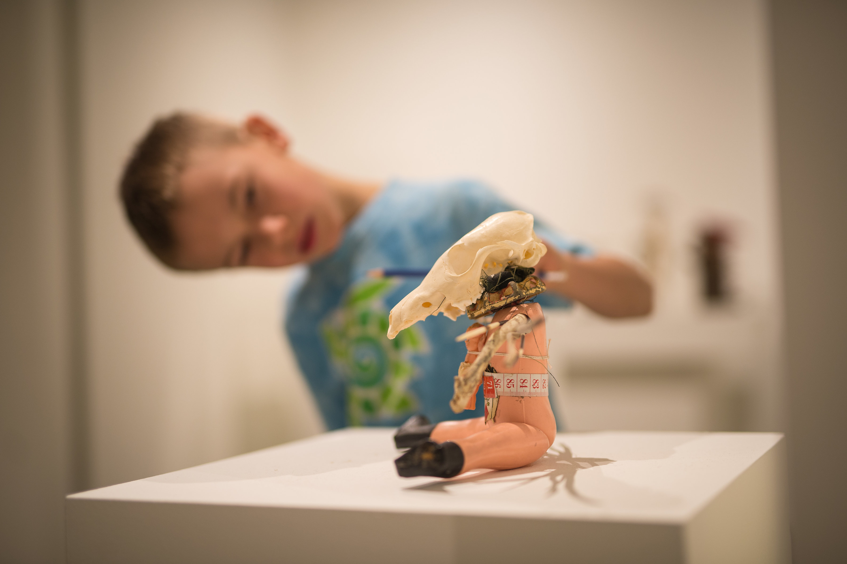
Youth Access Program launches at the Nelson Museum

Nelson, BC (January 22, 2023) - Children who spend time in museums are engaged, curious, and innovative. The statistics prove it, and children experience it every day at the Nelson Museum, Archives & Gallery.

The rotating gallery exhibitions, 2nd floor Museum, The REDress Project installation, Cold War Bunker, Shawn Lamb Archives, and the Nelson Sports Collection offer one-of-a-kind opportunities for youth in our community to engage with regional history, access critical contemporary art, explore their passions and talents, and learn outside the classroom. To remove barriers to access, the Nelson Museum has launched a brand-new membership model offering free memberships to all youth under 18.

A student studies one of the works in a gallery exhibition. Photo by Adrian Wagner

“We want Nelson’s young people to feel seen and welcomed in the Museum, and to think of the Museum as a safe space where they can explore critical ideas, be involved in a social paradigm shift, and further develop life-long curiosity,” says Nelson Museum Executive Director Astrid Heyerdahl. “We take investment in the health and happiness of our community’s youth very seriously, and the Nelson Museum is well-suited to provide an atmosphere of engagement.”

The Youth Access Program is funded by monthly sponsorships from local and regional businesses and individuals. The inaugural program sponsor is the philanthropic branch of Kalesnikoff Lumber, Kalesnikoff Cares.

“The Kalesnikoff Cares program aims to make a positive difference for local youth and families and the local environment and to support our employees in giving back to their own communities and causes,” says Dauna Ditson, Communications Manager at Kalesnikoff. “We are honoured to be the first funder, and I hope many more organizations come on board to support this initiative.”

The Nelson Museum has several businesses who have come on board to support the 2023 sponsorship season and we are currently seeking additional sponsors to support the entire 2023 season. If you are interested in sponsoring this program, please contact info@nelsonmuseum.ca. More details about the Youth Access Program and sponsorship details can be found at nelsonmuseum.ca.

-30-

