Research on Doreen Heelas

Compiled by Saanich Archives staff, with assistance from Sherry Robinson, a volunteer at Esquimalt Archives

18 June 2021

Doreen Ellen Heelas was born in 1907 in London, England. Her parents were Ernest George and Ella Frances Jane Hetcher Heelas. She immigrated to Canada in 1919, and the 1921 census lists her in Armstrong BC living with her mother. A search of directories shows her living in Vernon BC in the late 1920s and early 1930s. Her occupation was stenographer. By 1936, she was living in Vancouver and working as a stenographer for the federal government Dept. of Indian Affairs. She continued to live in Vancouver until her death in 1984.

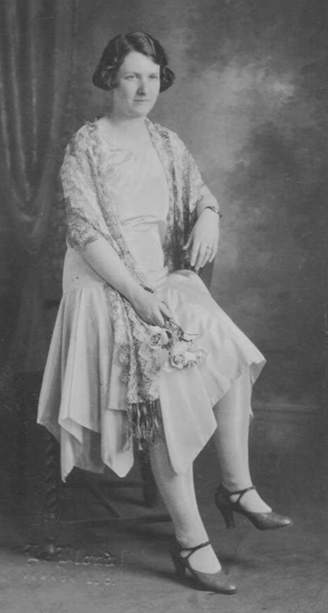

Photo of Doreen Heelas probably taken in the 1920s, found on Ancestry.

<https://www.ancestry.com/search/collections/1093/?name=_Heelis&count=50&fh=1050&fsk=MDs0OTs1NTA-61-&pgoff=11>

Additional information we found online:

She participated in the “Stanley Park in Pictures” exhibition at the Vancouver Art Gallery in 1946. <http://www.sim-publishing.com/bca/heelasd.htm>

City of Vancouver Archives and UBC Rare Books and Special Collections each have one of her works.

<https://searcharchives.vancouver.ca/painting-and-drawing-of-brock-house>

<https://open.library.ubc.ca/collections/framed/items/1.0214780>

She is listed in the Vancouver Public Library’s BC Artists Files. <https://www.vpl.ca/bcartistsfiles>

She did some writing for the Vancouver Sun including:

“So … We Went to Stanley Park” [this article she also illustrated]. 14 Jul 1945 <https://www.newspapers.com/clip/26559618/the-vancouver-sun/>

“Welcome, South Sea Islanders”. 18 Feb 1950 <https://www.newspapers.com/newspage/491709091/>

Doreen Heelas’ death certificate:

<http://search-collections.royalbcmuseum.bc.ca/Image/Genealogy/bd988a87-67a4-47df-a541-95e3c8cd62c5>