Canadian Heritage Funding Portal (CHFP)
Museums Assistance Program

Getting Started: How-To Videos, Portal Overview, Tips, and FAQ

How-To Videos (Applicant Profile and GCKey) 2
Overview of Submitting an Application through the Canadian Heritage Funding Portal (CHFP) 3
How to Modify an Organization Profile 5
How to Find Draft and Submitted Applications 9
How to Share my Organization 11
Canadian Heritage Funding Portal Frequently Asked Questions 15

How-To Videos (Applicant Profile and GCKey)

Note: If you previously applied for funding through the Canadian Heritage Funding Portal, you do not need to set up your Applicant Profile again.

Applicant Profile How-To Video
These are links to a video on YouTube (EN) that provide an overview on how to complete the Applicant Profile section of the Canadian Heritage Funding Portal.
https://youtu.be/PmbBEZ3b6lg

GCKey How-To Video
These are links to a video on YouTube (EN) that provide an overview on how to create an account in the Canadian Heritage Funding Portal.
https://youtu.be/eM72xXaODQU

Overview of Submitting an Application through the Canadian Heritage Funding Portal (CHFP)

- Applications for the Museums Assistance Program will be accepted through the new Canadian Heritage Funding Portal (CHFP). With the CHFP, you will be able to perform online transactions easily, such as:
- Managing your organization’s information;
- Submitting your funding application; and
- Tracking the status of your application.

- In order to apply through the portal, you will need to complete a three-step online application process (1 - Create a User Profile, 2 – Register your Organization and 3 - Submit an Online Application Form), as well as upload the required documents prior to the deadline.

- There are two ways to sign into the Canadian Heritage Funding Portal: through a Sign-In Partner or with a GCKey.

  - You can access the CHFP through a Sign-In Partner site. Sign-In Partners are companies and organizations (such as financial institutions) that have partnered with SecureKey Technologies to enable their customers to use their online credentials (e.g., card numbers or user names and passwords for an existing Canadian bank account) to access Government of Canada services. Using a sign-in partner is convenient because you don’t have to remember a different user ID and password; you already know your login information because you likely use it on a regular basis.

  - You can also access the CHFP with a GCKey. GCKey is a service that issues credentials (a username and password) for accessing government services online. This is a unique electronic credential that allows you to communicate securely with online-enabled government programs and services. GCKey is a good option if you don’t have a sign-in partner or prefer not to use one.

- To complete your Client Profile, you will need the following documents:
  - Proof of your organization’s legal status (letters patent/incorporation documents, partnership agreements, constitution or bylaws or other recognized documentation); if your organization is an unincorporated association, ad hoc committee or trust without any by-laws or a constitution, you can attach a copy of meeting minutes or a list of your controlling members.
  - Direct Deposit Enrollment Form, stamped by a financial institution or accompanied by one supporting document (a void cheque, banking letter, or management letter). Direct Deposit Enrollment Forms can be downloaded from the portal.
While you may have already submitted these documents in the past, you will need to upload them to your Client Profile the first time you apply online through the new portal.

- Browser: The Canadian Heritage Funding Portal works best with Chrome or Edge browsers. The CHFP does not work well with Explorer.

Our support team is available from Monday to Friday from 8:30 a.m. to 5:00 p.m. (Eastern Standard Time) to assist you with any technical issues or questions related to the online application. Here is how you can reach us:

Telephone: 1-866-811-0055
TTY (Teletype for the hearing impaired): 1-888-997-3123
Email: PCH.info-info.PCH@canada.ca

How to Modify an Organization Profile

Step 1: Navigate to My Organizations (2 methods):
Option A: Select “My Organizations” from drop-down menu (second menu from the top)
Option B: Select “Register or Manage an Organization” under the “Available Options”.
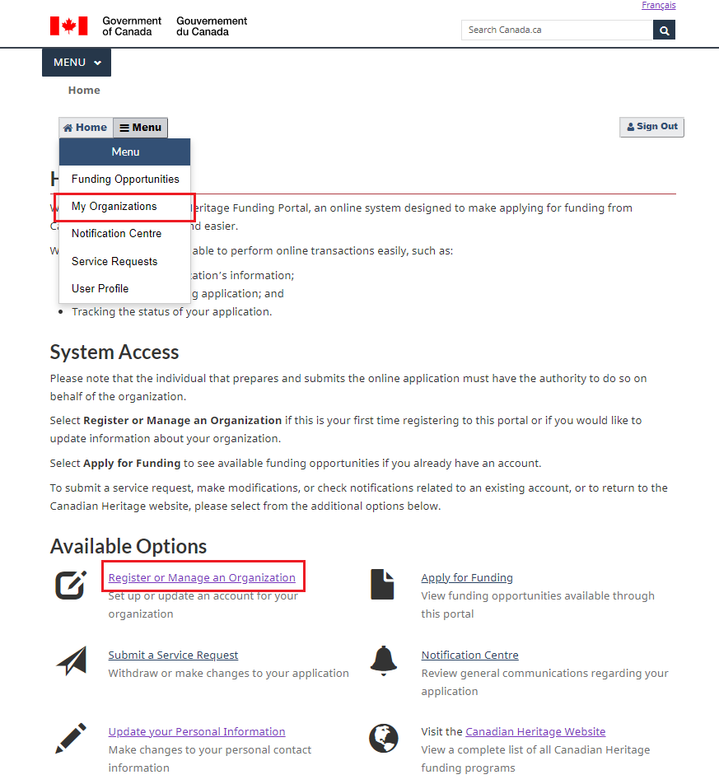

Step 2: Enable the editing of a registered organization (2 methods)
Find the tile representing your organization and select “Edit/View”.
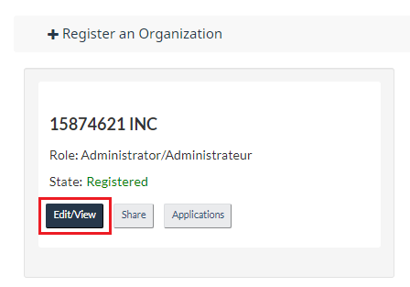
Option A) Select the “Edit” button in the section entitled “Your Organization” (button located at the top of the page, under the title).
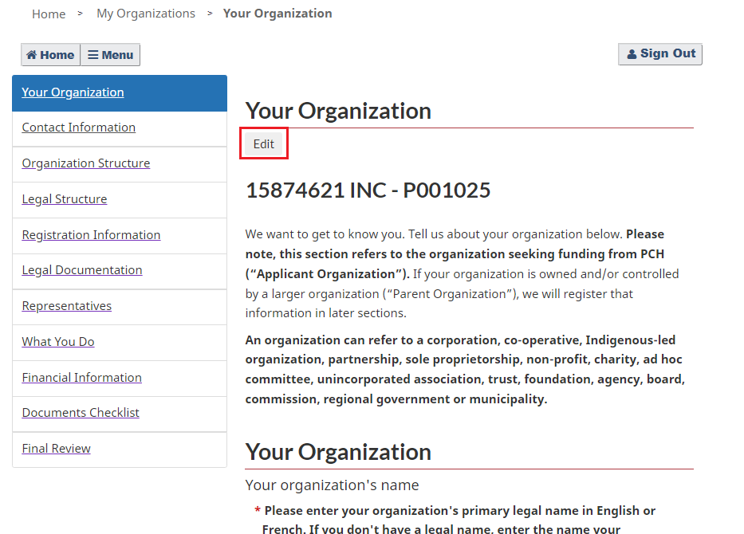
Option B) Select the “Edit” button in the Validation section (bottom right-hand corner of the screen).
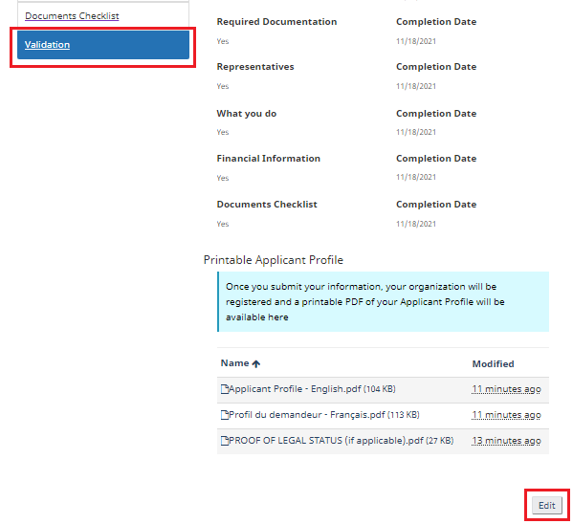

Step 3: Edit the organization profile
Note: An organization’s Legal Name cannot be changed once its profile has been submitted. To change an organization’s legal name, a new organization profile must be created.

Step 4: Submit the edited profile
Select the “Validation” section of the Organization Profile.
Click “Submit”.
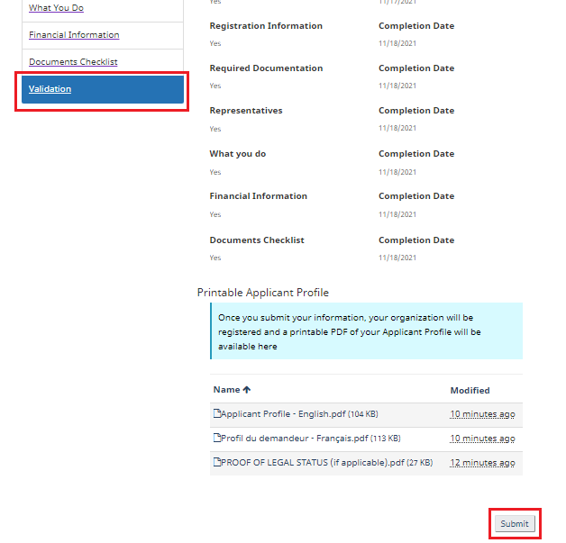

How to Find Draft and Submitted Applications

Step 1: Navigate to My Organizations (2 methods):
Option A: Select “My Organizations” from drop-down menu (second menu from the top)
Option B: Select “Register or Manage an Organization” under the “Available Options”.

Step 2: Access list of applications associated with your organization
Find the tile representing your organization and select “Applications”.
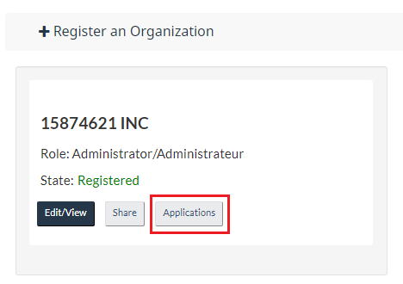
A list of all applications for your organization will appear:
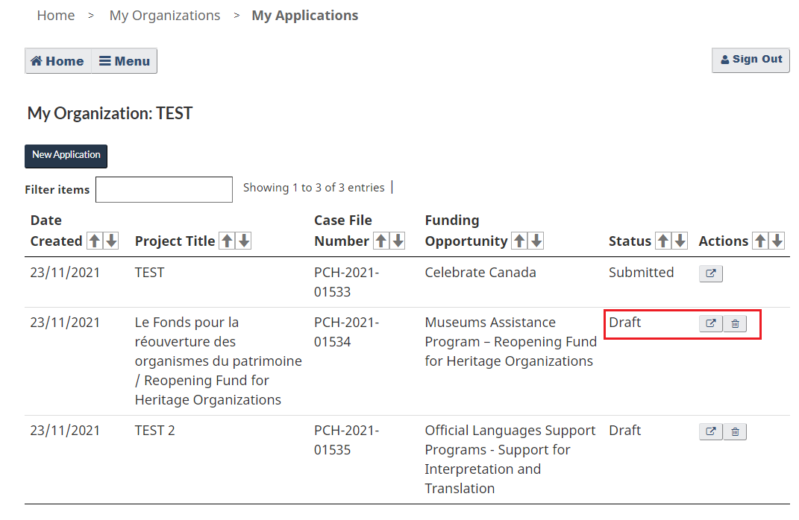
You may open (and edit) or delete draft applications (icons under the Actions column).

How to Share my Organization

Step 1: Ensure that the collaborator you wish to share with has a User Profile in the portal:
If the person you wish to share with does not yet have a User Profile associated with their email address, they must create one in the Canadian Heritage Funding Portal.
To create a User Profile, sign in using a partner site or register using a GCKey account. Complete the profile and select Save.
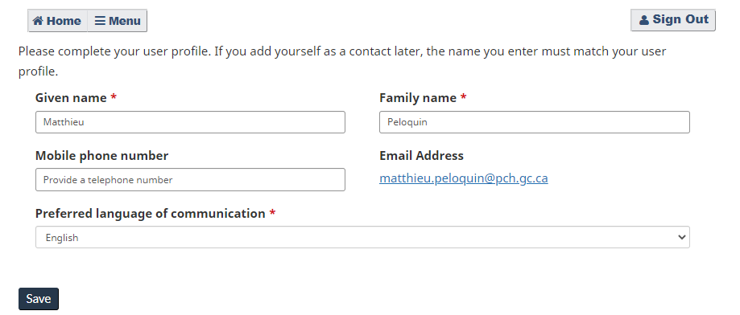

Step 2: Navigate to My Organizations (2 methods):
Option A: Select “My Organizations” from drop-down menu (second menu from the top)
Option B: Select “Register or Manage an Organization” under the “Available Options”.

Step 3: Share your Organization:
Find your organization’s tile and select “Share”.
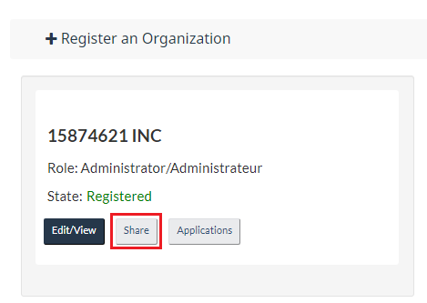

You will be directed to a new page, where a list of collaborators with access to your organization will appear. To share your organization, select “Add collaborator”.
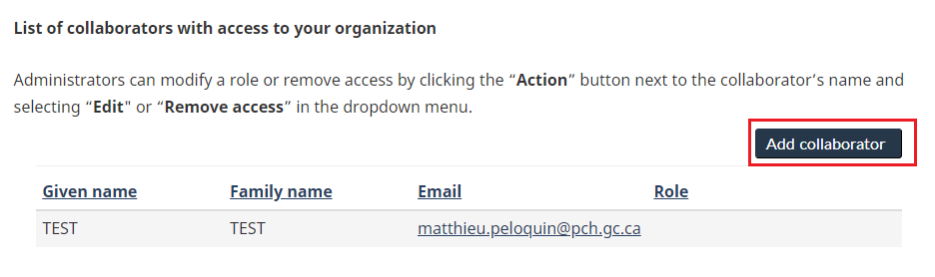

A popup window will appear.

Step 4: Select the person with whom you wish to share your organization:
Add the email address of the person you wish to share your organization with and specify which role you wish to grant them.
If the sharing is successful, the person with whom you shared will receive a confirmation email from the system with instructions on how to access the organization and any applications associated with the account.
Notes:
- The email address must match the one they used to create their User Profile.
- A maximum of three sharing attempts are permitted within a 24-hour period.
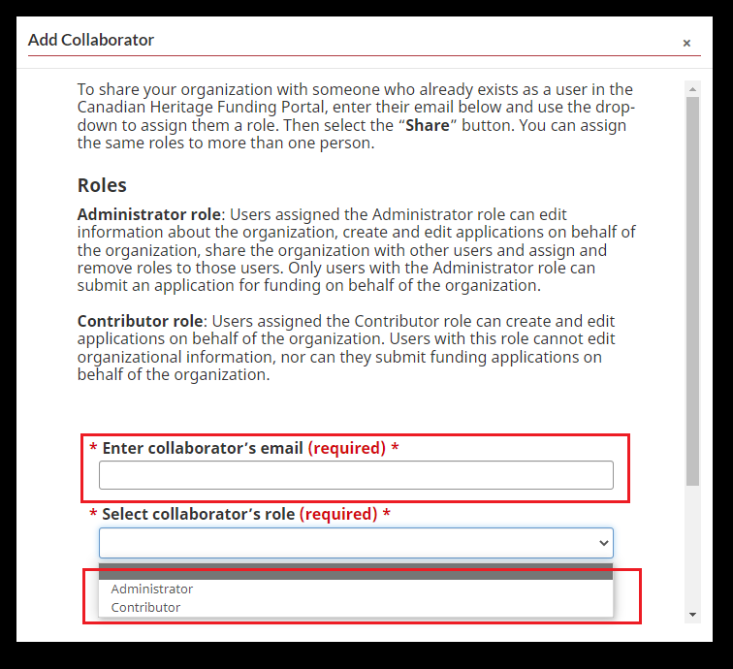

Canadian Heritage Funding Portal Frequently Asked Questions

The Canadian Heritage Funding Portal (CHFP) is a secure platform for Canadians to access various grants and contributions programs within the Department and apply for funding online.

This online system was developed as part of the Department’s ongoing efforts to modernize the delivery of its grants and contributions programs, and was designed to make the process of applying for funding, reporting and interacting with programs faster and easier.
With the CHFP, you will be able to perform online transactions easily, such as:

- Managing your organization’s information;
- Submitting your funding application; and
- Tracking the status of your application.

The CHFP has been designed with your needs in mind and, ultimately, will help speed up the application process. For example, information that has traditionally been requested every year, such as contact information/address, organizational by-laws and documents of incorporation, will only need to be submitted once, during the initial application process. This means that your information will be saved and accessible for subsequent applications. Not only will this help you save time, it will also eliminate the need for hard copy applications with original signatures.

In order to apply through the portal, you will need to complete a two-step online application process (a Applicant Profile and an online application form), and upload the required documents prior to the deadline.

The portal can be accessed through your internet browser using the following link:
https://pch-financement-funding.canada.ca/en-CA/.
Note: At any point in the application process, you can toggle between French and English by clicking the link in the top right corner.

Our support team will be able to assist you should you have any questions or if you encounter any technical difficulty.

Q1. I cannot access the portal. / I am experiencing issues with my browser. What should I do?

The use of a recent version of Microsoft Edge or Google Chrome is recommended. It is recommended to install the latest version of the browser you wish to use from the list provided above for the best user experience. The use of Internet Explorer or Firefox is not recommended as users are likely to experience issues; Safari users working on a Mac platform may also encounter issues.

Q2. How do I sign on to the portal?

There are two ways to sign into the Canadian Heritage Funding Portal: through a Sign-In Partner or with a GCKey.

- You can access the CHFP through a Sign-In Partner site. Sign-In Partners are companies and organizations (such as financial institutions) that have partnered with SecureKey Technologies to enable their customers to use their online credentials (e.g., card numbers or user names and passwords for an existing Canadian bank account) to access Government of Canada services. Using a sign-in partner is convenient because you don’t have to remember a different user ID and password; you already know your login information because you likely use it on a regular basis.

- You can also access the CHFP with a GCKey. GCKey is a service that issues credentials (a username and password) for accessing government services online. This is a unique electronic credential that allows you to communicate securely with online-enabled government programs and services. GCKey is a good option if you don’t have a sign-in partner or prefer not to use one.

Q3. Who should set up the applicant profile and register the organization?

The individual that sets up the Applicant Profile should be someone who has knowledge of the organization’s structure and has access to information such as incorporation documents and banking information. This user does not need to be the same person that will be submitting or authorizing applications on behalf of the organization.

Q4. How can I share my organization and/or application with other people in my organization?
Once you have started or registered your organization in the portal, find the organization’s tile under My Organizations and select the Share button. There you will be able to enter the email address of other users who you would like to share access with. You can assign either Administrator or Contributor roles to these individuals (further details about the roles can be found on the Share page in the portal).
Please note, the user who you want to share with must first complete a User Profile in the portal by signing in with either a Secure Partner or a GC Key and entering their contact information. The email address you enter for each individual to give them share access must be the same email address that they have entered for themselves in their User Profile.
For security reasons, you are allowed three “shares” or share attempts per day.

Q5. What documents do I need to complete my Applicant Profile?

To complete your Applicant Profile, you will need the following documents:

- Proof of your organization’s legal status (letters patent/incorporation documents, partnership agreements, constitution or bylaws or other recognized documentation); if your organization is an unincorporated association, ad hoc committee or trust without any by-laws or a constitution, you can attach a copy of meeting minutes or a list of your controlling members.
- Direct Deposit Enrollment Form, stamped by a financial institution or accompanied by one supporting document (a void cheque, banking letter, or management letter). Direct Deposit Enrollment Forms can be downloaded from the portal.

While you may have already submitted these documents in the past, you will need to upload them to your Applicant Profile the first time you apply online.

Q6. Can I change the email address associated with my user account?

Once you have created an account, the email address associated with your user account cannot be changed.

You will have to contact the Client Support to obtain assistance:

Email: info@pch.gc.ca
Telephone: 1-866-811-0055 (toll-free)
Call toll-free from all regions, Monday to Friday, 8:30 a.m. to 5:00 p.m. (Eastern time)
TTY: 1-888-997-3123 (for people who are deaf, hard of hearing or speech impaired)

Q7. Where can I find the glossary?

A link to the glossary with definitions of business terms can be found under “My Organizations.”

Q8. How can I know if I am eligible to apply for funding?

Consult the webpage of the program you are interested in applying for. A list of Canadian Heritage’s funding programs can be found at Funding - Culture, history and sport - Canada.ca

Q9. How can I find my application ID?

Once you have submitted an application, you will receive a confirmation email. Your application ID will be in that email.

Q10. I do not have access to a scanner. Can I take a picture with my phone?

If the image is clear and readable, a photo of the signed documents will be accepted (in jpeg format).

Q11. I do not have access to a printer. Are electronic signatures accepted?

Electronic signatures are accepted for most documents (except the Unincorporated Responsibility Form which requires wet signatures).

Q12. How can I see the applications I have started or submitted? How do I know if my application was submitted successfully?

Started and completed applications are found under your organization’s tile within the menu under “My Organizations.” Select the Applications button. Here, a list of all in-progress and submitted application details can be found; the status of the application is displayed.

Clients who submit an application will receive an automatic acknowledgement message confirming receipt of their application. Remember to check your junk mail folder, then contact us if necessary.

Q13. I submitted an application form and I realized I made a mistake. Can I make changes or submit another application?

Once the application has been submitted, no changes can be made on the portal. To make a change, select Service Requests under the Menu. On the “My Service Requests” page, you can select “Create a service request.” You will be able to select a submitted application and send a request to reopen or withdraw your funding application. Please enter the reason for your request in the Description box. A program officer will follow up with you regarding your request.

You can also get in touch with PCH:

Email: info@pch.gc.ca
Telephone: 1-866-811-0055 (toll-free)
Call toll-free from all regions, Monday to Friday, 8:30 a.m. to 5:00 p.m. (Eastern time)
TTY: 1-888-997-3123 (for people who are deaf, hard of hearing or speech impaired)

Note: Do not submit another request.

Q14. I cannot use the online portal. How else can I apply?
Should you be unable to access the new system or apply online for any reason, please contact our support team.
Our support team is available from Monday to Friday from 8:30 a.m. to 5:00 p.m. (Eastern Standard Time) to assist you with any technical issues or questions related to the online application, and can put you in touch with program staff who will be able to guide you as to other methods of application as required (telephone, email, mail). Here is how you can reach us:
Telephone: 1-866-811-0055
TTY (Teletype for the hearing impaired): 1-888-997-3123
Email: info@pch.gc.ca

