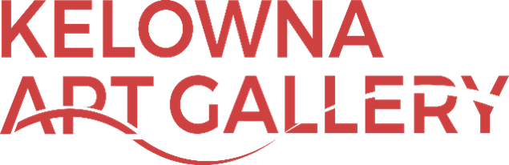

Job: Part-Time Gallery Assistants
Hourly Wage: $16.00
Hours: 6-20 hrs. per week
Start Date: July 2022
The Kelowna Art Gallery is currently seeking one individual to join our team as a
Part-time Gallery Assistant. You will have a regular shift on Saturday and Sunday during the day, an evening shift on Tuesday and will have the opportunity to take additional on-call shifts during the week when extra-coverage is needed.

This position assists with all aspects of visitor services, specifically reception admissions, class and camp registrations, visitor statistics and customer service support. Duties also include maintaining the reception area clean and tidy and providing security to the Gallery by monitoring our video surveillance system. Shifts include evenings and weekends. Additional work hours may be available for on-site assistance with Gallery special events and/or facility rentals.

Qualifications:
- Must enjoy working with the public and meeting new people
- Must possess customer service experience and experience handling cash
- Must be able to work as a team member
- Must possess excellent communication skills
- Must be interested in the visual arts, and the cultural attractions in this region
- Must be proficient in Microsoft Word, and Excel, Experience with Square is an asset
- Must be able to multitask and work with frequent interruption
- French language is an asset
- Must have flexible availability

Please email resumes and cover letters to hr@kelownaartgallery.com

The Kelowna Art Gallery is an equal opportunity employer and encourages applications from self-identified members of underserved communities as well as visible and invisible minority groups. We thank all who express interest in this position, however, only those selected for an interview will be contacted. No phone calls please. We will only consider applications received by email. This job posting will close on Sunday, June 19.

KELOWNA ART GALLERY
1315 Water Street, Kelowna, BC V1Y 9R3
Tel: 250.762.2226 Fax: 250.762.9875
www.kelownaartgallery.com
hr@kelownaartgallery.com

