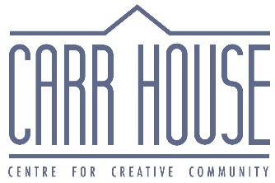
For Immediate Release
Contact
(250) 383-5843
carrhouse@telus.net
Happy 150, Emily Carr!
Carr House celebrates Emily Carr’s 150th birthday.
(Victoria, BC November 13 2021) Emily Carr turns 150 on December 13 and Carr House is celebrating with a weekend of festivities! Join us for a poetry afternoon, a book launch, and an open house.
The weekend begins on Saturday, December 11th at 2pm with the award ceremony for the City of Victoria’s Emily Carr 150 Poetry Contest. The winning poems will be on display at Carr House during this event. Following the award presentation, there will be poetry reading from Poet Laureate John Barton and Youth Poet Laureate James Summer.
Sunday, December 12th will be the official release of Unvarnished: Autobiographical Sketches by Emily
Carr. Edited by Kathryn Bridge, this new book offers a look at the unpublished and highly personal writings of Emily Carr. Editor Kathryn Bridge and curator India Young will be present to discuss this exciting new publication from the Royal BC Museum. This event begins at 2pm. Copies of the book will be available for purchase and signing.

On December 13th, Carr House will open its doors from 10am to 6pm to wish Emily a happy 150th birthday. Come explore the house, grab a birthday treat, or make Emily a birthday card to celebrate the life of this iconic Canadian artist and writer.

All events will take place at Carr House at 207 Government Street. During these weekend festivities, sculptures by local artist Tanya Bub will be on display in the gardens. Masks and proof of vaccination is required to go inside Carr House. No need to register or buy tickets, just come by!
You can find more information on these events at our website at https://carrhouse.ca/upcoming-events. If you have any questions, contact us at carrhouse@telus.net or (250) 383-5843.
Carr House, birthplace of famed writer and artist Emily Carr, is a provincial and national historic site at 207 Government Street. Victoria, BC. It is open to tours in the summer and offers year-round community programming based on Emily Carr’s life themes: art, writing, nature and the environment, indigenous peoples, feminism, animal rights, emerging creativity and mentorship.

-30-

For more information, please call Pascale Halliday at (250)383-5843 carrhouse@telus.net

