Press Release

Media contact:
Arin Fay, Curator
Touchstones Nelson: Museum of Art and History
curator@touchstonesnelson.ca
250.352.9813

For immediate release

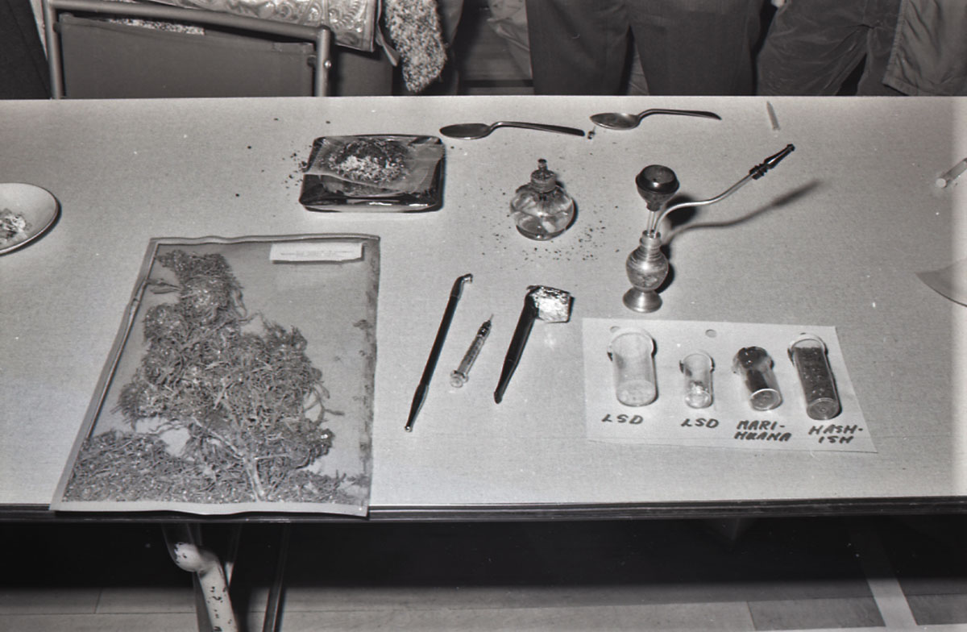
High times at Touchstones Nelson Museum
Police set up a display of drug paraphernalia during a presentation to high school students in 1970. Photo from the Nelson Daily News collection at the Shawn Lamb Archives.

Nelson, BC (November 16, 2021): Shakespeare (may have) smoked it. Bill Clinton definitely smoked it, but didn’t inhale. The Kootenays grew it - a lot of it. Canada legalized it. And now, Touchstones Nelson Museum is doing a show about it.

The Grow Show, which runs November 26, 2021 to February 27, 2022 explores cannabis culture in the Kootenays through many different lenses, including agriculture, economy, culture, politics and community perspectives via photography, video, art, artifacts and the written word.

“There is both enthusiasm and reticence to talk about cannabis culture in the Kootenays,” says Curator Arin Fay. “There was a mixed bag of responses: nostalgia, bitterness, cautionary tales, collateral damage, gold-rush-fever and rose-coloured reminiscence, to name a few.” These tales, combined with paraphernalia, recreated scenes, and placebo plants, convey a small part of its vast, complicated history”.

Idealized and pragmatic perspectives are featured on both sides of the legal divide, and Fay, with support from the community, considered carefully the material that would be included, to ensure the narrative being presented is as even-handed as possible. “There is no unabridged telling of this story - no leather-bound book that we can go to for the facts - history is about perspective and the proof that was left behind, which is challenging when so much is underground, goes unsaid, and has reason to hide,” she adds.

The Grow Show opens Friday, November 26 from 7-9 pm. Masks and proof of vaccination are required. For more information visit www.touchstonesnelson.ca

Touchstones Nelson: Museum of Art and History acknowledges that the Museum resides on the traditional unceded territory of the Sinixt, and Ktunaxa Nations. We would like to thank and acknowledge the Sinixt Confederacy, Yaqan Nukiy Ktunaxa Nation, and the Métis people for the opportunity to live, learn, and share in cultural experiences in this incredible place.

-30-

