White Rock Museum & Archives presents:
The White Rock History Quiz Episode 3
October 29, 2021 – White Rock, BC: The White Rock Museum & Archives is proud to present our new video! The White Rock History Quiz Episode 3 features questions about the history of the arts in White Rock.
White Rock History Quiz Episode 3 can be found on YouTube at: https://www.youtube.com/watch?v=7IFSNeDJr1Y&t=2s
Join Hugh Ellenwood, Archives Manager with White Rock Museum & Archives, on this engaging and challenging journey into White Rock’s art scene. White Rock Museum & Archives is grateful for the technical and production assistance of Mark Roland Henning from Boutique Empire Studios in creating this video presentation.
“Historically White Rock has been a very artistic town. Maybe it’s the beautiful location that attracts people of an artistic nature. I hope that people will have fun doing this quiz, as they learn about the history of the arts in White Rock.” -Hugh Ellenwood, Archives Manager
Staff and leadership at White Rock Museum & Archives are committed to reaching out to and engaging the White Rock community. Our mission is to preserve our community’s heritage, reveal our community’s story, share stories worth telling, and welcome everyone.
More videos are in development for the future, as well as a video adaptation of Hugh Ellenwood’s popular historical walking tours, so subscribe to the White Rock Museum & Archives YouTube page to receive notifications: youtube.com/channel/UCDx6P4mlgSPt-oubSgnQEfQ

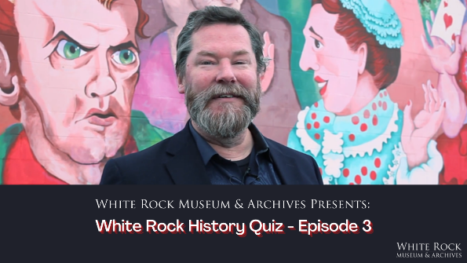

The White Rock Museum & Archives is located at 14970 Marine Drive in the historic 1912 train station on the waterfront. For more information, please visit www.whiterockmuseum.ca or call 604-541-2221.

Media Inquiries Content Inquiries
Melissa Borgerson | Marketing Coordinator Hugh Ellenwood | Archives Manager
604-541-2222 604-541-2225
marketing@whiterockmuseum.ca archives@whiterockmuseum.ca

xxx

