OBJECT LIST

IMAGE | OBJECT ID # | OBJECT NAME | DESCRIPTION | CONDITION
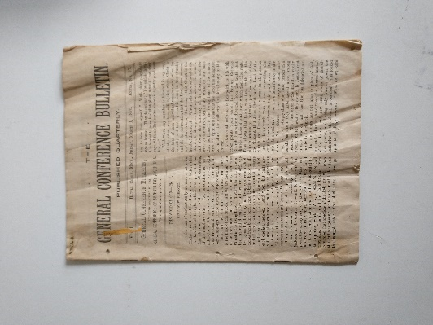  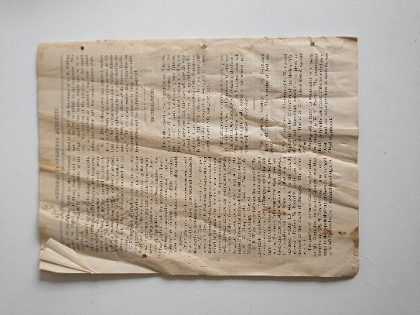 | 6 | Magazine | This magazine is the General Conference Bulletin published by the General Conference of Seventh-Day Adventists on March 1, 1895. | Fair
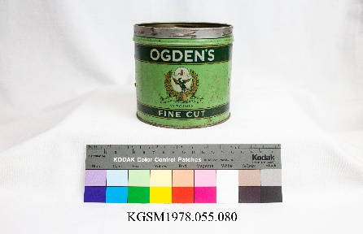 | 8 & 9  Two available, see pictures. | Tin, Tobacco | Round, two toned green tobacco tin with gold & white lettering & design. 8 has no lid. | Fair
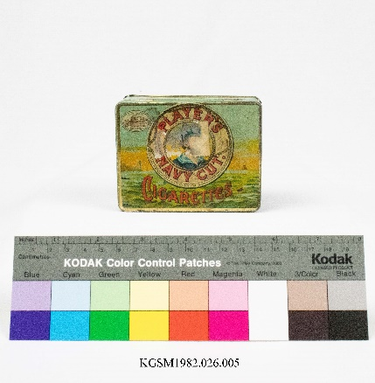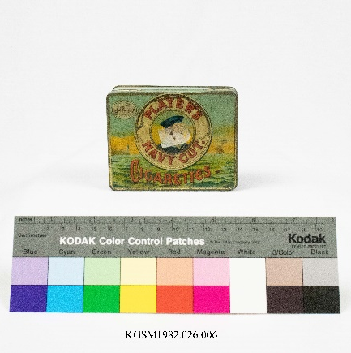 | 11, 12, 13  Three available, see photos. | Tin, Tobacco | Rectangular blue tobacco tin with red lettering "Player's Navy Cut Cigarettes". On the top there is a depiction of a sailor's profile framed by a life preserver; seascape behind, trademark of castle; hinged lid. | Fair
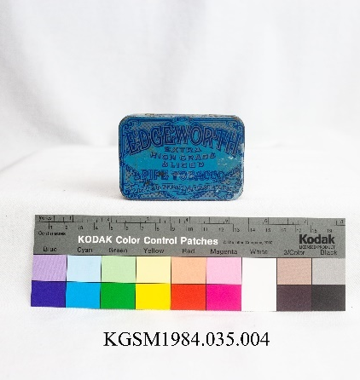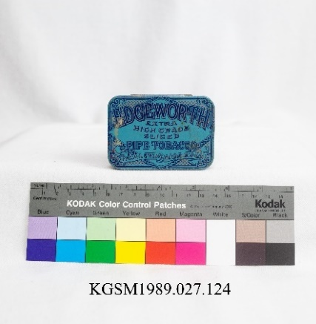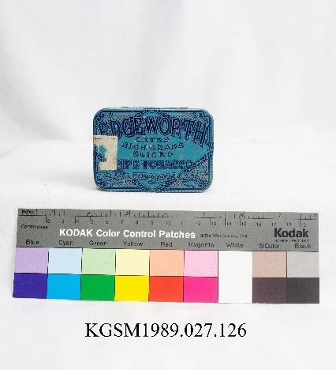 | 16, 17, 18  Three available, see photos. | Tin, Tobacco | Small blue tobacco tin. "Edgeworth extra high grade sliced pipe tobacco." | Fair
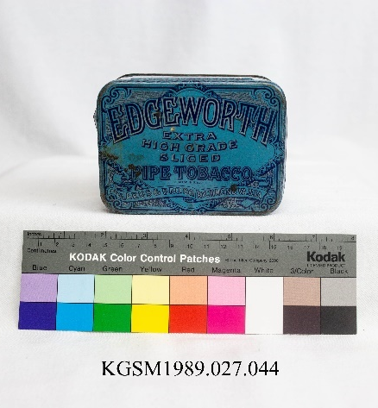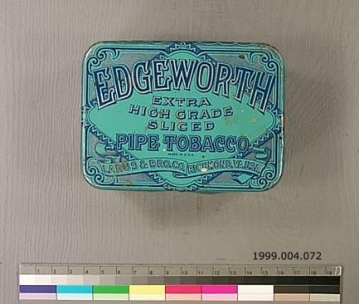 | 19, 20  Two available, see photos. | Tin, Tobacco | Medium blue tobacco tin. "Edgeworth extra high grade sliced pipe tobacco." | Good
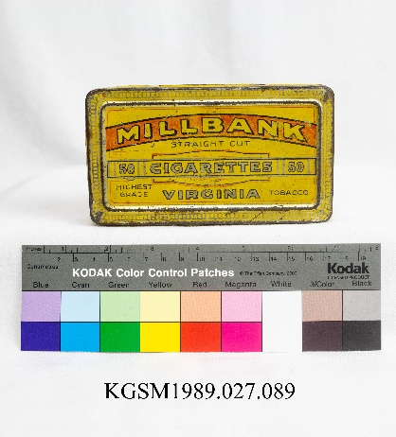 | 21 | Tin, Tobacco | Yellow rectangular tin. "Millbank straight cut. 50 cigarettes. Highest grade Virginia tobacco." | Fair
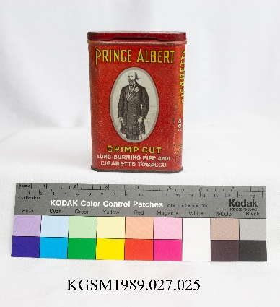 | 22 | Tin, Tobacco | Red pocket tobacco tin. "Prince Albert Crimp Cut." Hinged lid. | Fair
 | 24 | Tin, Tobacco | Red pocket tobacco tin. "Forest and Stream Tobacco" Logo is a duck flying. | Fair
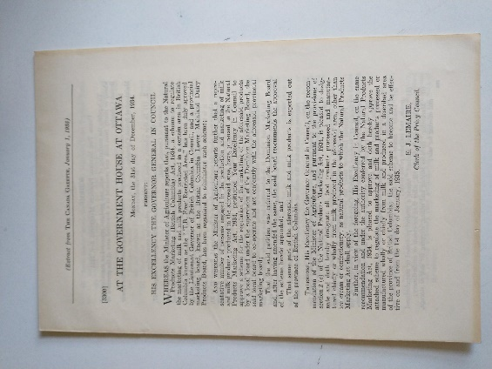 | 29 | Booklet | Small booklet with excerpt from "The Canada Gazette January 1, 1935" about dairy industry updates to regulations. | Fair
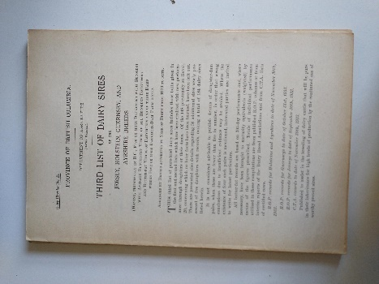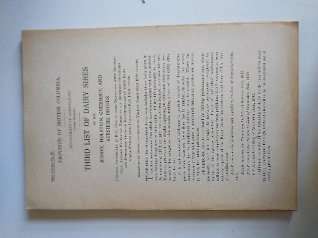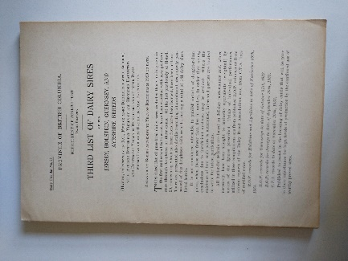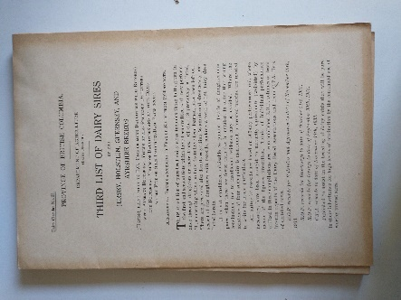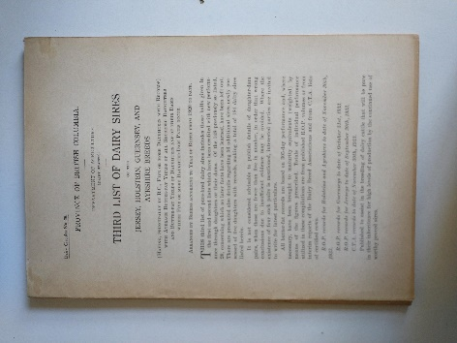 | 32 – 36  Five available, see photos. | Booklet | Small booklet with a list of dairy sires. "Daily Circular No. 25 Province of British Columbia Department of Agriculture (Dairy Branch)" and "Third List of Dairy Sires of the Jersey, Holstein, Guernsey and Ayrshire Breeds" printed on cover, bound with two staples. Includes a list of names of all registered sires from 1920-1934. | Good
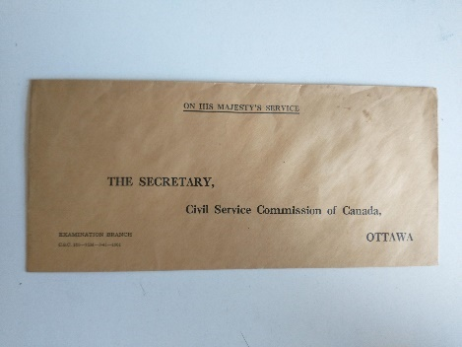 | 45 | Envelope | Brown paper envelope with "On His Majesty's Service" and "The Secretary, Civil Service Commission of Canada, Ottawa" in black ink on front. Unused. | Fair  (42 is poor, 45 is good, the rest are fair).
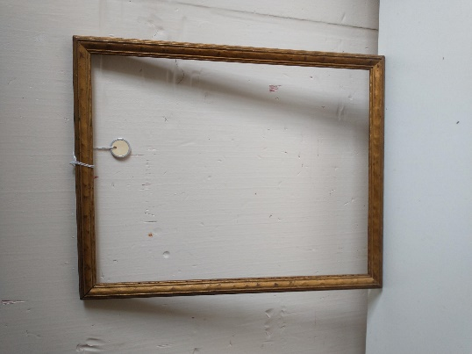 | 46 | Picture Frame | Empty wooden picture frame, painted gold. Nail with loop of wire on the back.  31 cm x 38.5 cm. | Good
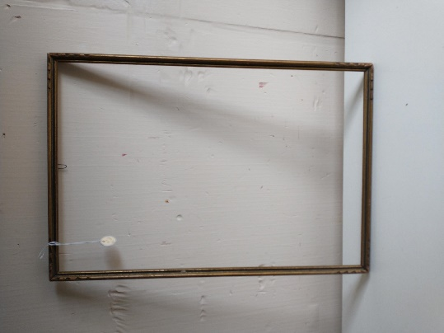 | 47 | Picture Frame | Empty wooden picture frame, painted gold. Nails on back, notch design in corners.  32 cm x 48 cm. | Good
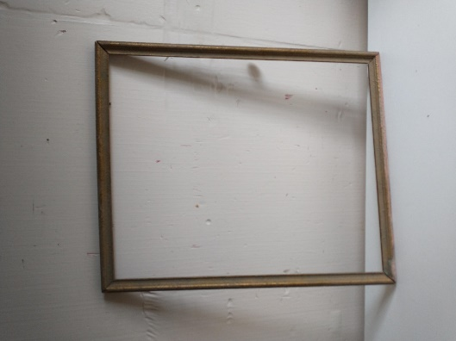 | 48 | Picture Frame | Empty wooden picture frame, painted gold. Two eye hooks with wire on the back. It is not square or flat. In the photo you can see that the top is not parallel to the bottom.  38 cm x 46 cm. | Fair

