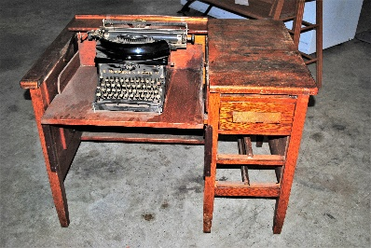  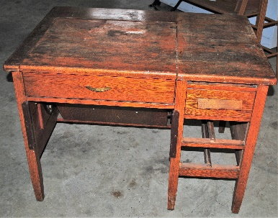 | Typewriter desk with Remington Typewriter  Once used in our office.  Surplus to our requirements.
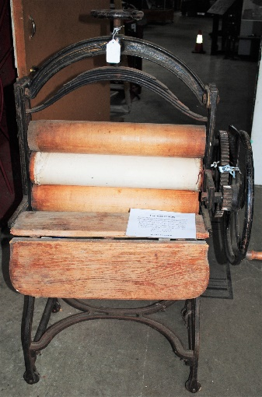  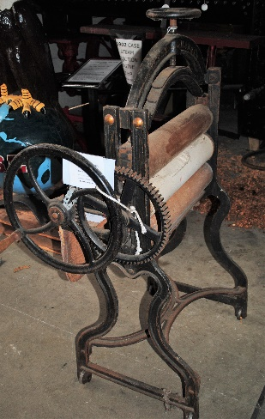 | Peerless Mangle with three rollers.  In good condition.  Surplus to our requirements.  2018.2.16 de-accessioned March 2021.

