Press Release

Media contact:
Astrid Heyerdahl, Executive Director
Touchstones Nelson: Museum of Art and History
director@touchstonesnelson.ca
250.352.8200

For immediate release

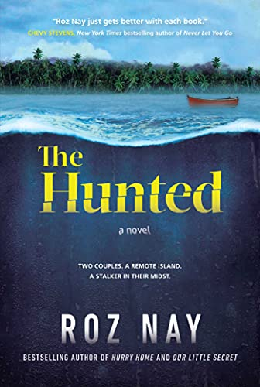
Roz Nay launches new book at Touchstones Nelson Museum

Nelson, BC (June 18, 2021): Local author Roz Nay has published a new book, The Hunted (Simon & Schuster), a story about two couples who meet backpacking across Africa - what starts as friendship soon turns deadly in this nail-biting thriller.

Touchstones Nelson: Museum of Art and History will be hosting a book launch for The Hunted on Tuesday, July 6 at 7 pm. Space is limited and registration is required. Please email shop@touchstonesnelson.ca to reserve your space.

The Hunted is Nay’s third book; her debut novel, Our Little Secret, was a national bestseller, won the Douglas Kennedy Prize for best foreign thriller in France, and was nominated for the Kobo Emerging Writer Prize for Mystery and the Arthur Ellis Best First Novel Award. Hurry Home, her second novel, is also a bestseller, and is available in the Shop.

For more information about the novel please visit www.roznay.com.

-30-

