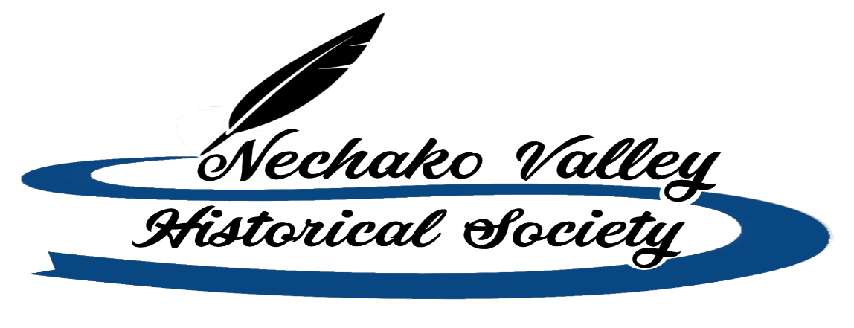
Box 1515
Vanderhoof, B.C. V0J 3A0

The Nechako Valley Historical Society is seeking a temporary Data and research person for the Vanderhoof Museum. This person will perform data entry activities to populate a new digital collection data base with previously accessioned objects.

Duties and Responsibilities

- Converting hard-copy records into digital records
- Correcting existing records to bring them up to archival standards.
- Cataloguing artefacts including identifying, data entry, photo documentation while observing proper conservation and storage techniques.
- Develop a photography process to ensure photographs are attached to the correct data base.
- Identifying, recording, and flagging anomalies such as accessioned objects/specimens with missing paperwork or incomplete paperwork.

Qualifications
- Has superior communication skills (written and oral)
- Meticulous attention to detail.
- Possess excellent interpersonal skills.
- Demonstrated ability to organize information and prioritize tasks and projects.
- Self-motivated and able to work well independently as well as collaboratively.
- Proficient with the Microsoft Office Suite.

Eligibility

- Prior experience with museum or museum collections management systems is an asset.
- Has a high level of computer literacy.
- Possesses excellent organizational, research and interpersonal skills.
- Is proficient in the English language, both written and spoken
- Preference given to candidates with previous work or volunteer experience in a museum, archives, or historic site.

Wages and hours

$16.00 per hour 35 hours a week

How to apply: Apply with a cover letter and resume by May 11, 2021 email to: Anne Davidson at adavidso@hwy16.com

Thank you to all applicants, however, only those short-listed for an interview will be contacted.

