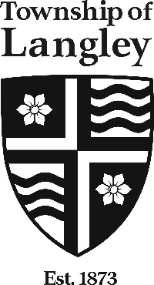 | Summer Career Placement 2021  Bulletin File #: 21-B001  Web Site: tol.ca  Job Title: Museum Assistant – Education Programs  Division: Arts, Culture and Community Initiatives  Hours of Work: Non-standard Hours and/or Non-standard Work Week  Hourly Wage: $22.09 per hour (2020 rates) plus 13% in lieu of benefits  Placement Date: Approx. May 17, 2021 to approx. August 27, 2021 (approx. start and end dates: subject change/dependent on  funding)
Applications are currently being accepted from a dynamic and committed individual to fill an auxiliary Summer Career Placement for the position of Museum Assistant – Education Programs from approximately May 17, 2021 to August 27, 2021 (approx. end dates are subject to change dependent on funding).

Duties and Responsibilities:
As a student employee with the Arts, Culture and Community Initiatives Division of the Township of Langley, the incumbent will work on short-term projects at the Langley Centennial Museum & Exhibition Centre. Summer Education projects will involve enriching school programming for children, families, and school groups with an eye to ensuring compliance with Public Health Orders relating to the COVID pandemic. The position will also work on preparing new programs and updating existing programs in preparation for the move to Salishan Place - a new reconciliation museum that will open in the spring, 2023.

The Museum Assistant – School Programs will be engaged in the following:
- Working with the Educator, review and revise as needed existing school programs to accommodate changes in the BC Curriculum established by the Ministry of Education
- Working with the Educator, review and revise as needed existing school programs to reflect input provided by the First Nations Education Programs Review Committee
- Update the Teaching collection inventory by cataloguing new acquisitions, thereby facilitating their use within existing school programs as well as the development of school and community travelling trunks which are planned for the near future
- Participate with, and supervise youth volunteers at a variety of community outreach events including parades and other special community events subject to Public Health Orders
- Assist the Educator in designing a new school program for implementation in the 2021-2022 school year
- Other duties as reasonably assigned

Qualifications, Knowledge and Skills required for this position include:
- University student entering third or fourth year of study, with courses in one or more of the following disciplines: Education, History, Science, Fine Arts, Museum studies, First Nations studies or other related field
- Computer skills, including experience-using Word is required; some knowledge of PowerPoint, Excel and desktop publishing would be an asset
- Excellent research and writing skills
- Excellent interpersonal skills, preferably with some experience in public relations or customer service
- Previous experience in a Museum environment would be an asset
- Experience working or volunteering in a museum, arts or education environment would be an asset.
- Previous experience working with children is considered an asset
- Bilingualism Fr. & Eng. is also considered an asset

This position is being offered pursuant to a federally funded employment program. Funding for the position is conditional on the applicant meeting the following criteria:
- Must be a Canadian student, legally entitled to study and work in Canada. You must be registered in the Young Canada Works inventory at www.youngcanadaworks.ca and you must be between the ages of 16 and 30. You must also have been a full-time student in the semester preceding the YCW job and intend to return to full-time studies in the semester following the YCW job. You must be willing to commit to a work assignment up to 16 weeks

The Township of Langley is committed to employment equity and is an equal opportunity employer. Accommodations will be provided as appropriate in any position to the point of undue hardship.

This position is defined by the Township of Langley as a position of trust (Child Safety). The successful candidate will be required to have a Police Information Check as a condition of employment (Note – Not required as part of the application process, however will be required upon consideration for employment).

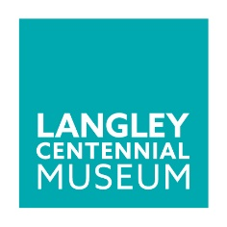
If you wish to pursue this exciting career in a growing community, please apply directly through our site at tol.ca/careers.

This competition will not close until the position is filled. We appreciate all applications; however, only short-listed candidates will be contacted.

The Langley Centennial Museum & Exhibition Centre is a community museum located in
Fort Langley, British Columbia. More information is available at http://museum.tol.ca
9135 King Street, Fort Langley, BC

