Press Release

Media contact:
Arin Fay, Curator
Touchstones Nelson: Museum of Art and History
curator@touchstonesnelson.ca
250.352.9813 x 275

For immediate release

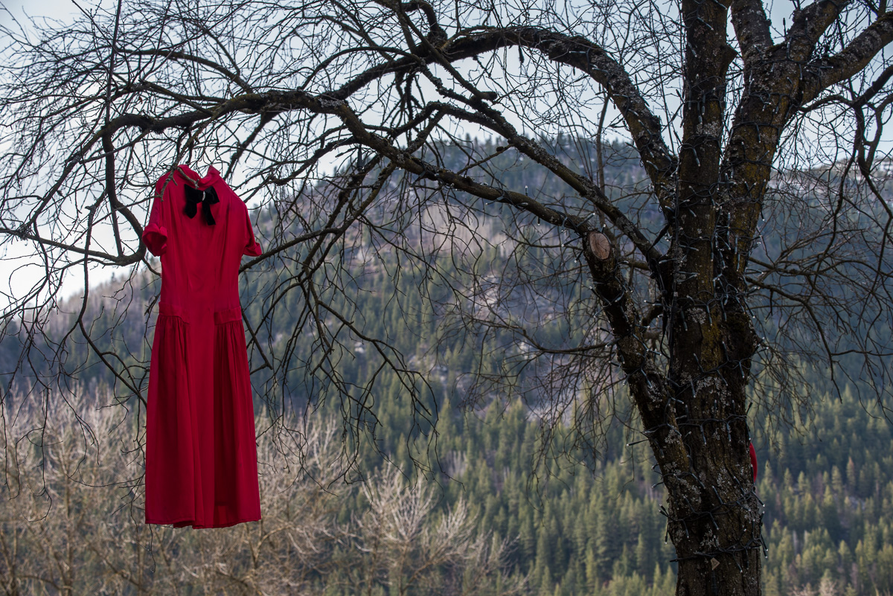
The REDress Project gains international recognition

Nelson, BC (April 7, 2021): The red dresses hanging at Touchstones Nelson Museum and Nelson’s City Hall have caught the eye of locals and visitors alike. They have ignited passionate conversations, conjured memories, and created a space to mourn. Having been exhibited across Canada, The REDress Project is a powerful symbol of Missing and Murdered Indigenous Women and Girls (MMIWG), and the movement is gaining recognition across the border as well.

The REDress Project, and Touchstones Nelson Museum, are featured in a recent article published in Vogue, one of the publishing giant Condé Nast’s flagship titles. The story features interviews with artist Jaime Black and Touchstones Nelson Curator Arin Fay, and shines a light on both Canadian and US statistics, illustrating that the issues of violence against Indigenous women is not just a Canadian problem.

(The REDress Project installed by Touchstones Nelson Museum at Nelson’s City Hall Plaza as a MMIWG memorial, and as a symbol of heartbreak and resilience. photo credit: Jeremy Addington, Taghum Hill Photography)

“Touchstones Nelson: Museum of Art and History is incredibly proud to be hosting Jaime Black’s ‘The REDress Project’ both in Gallery B and in the public space in front of City Hall,” says Fay. “Having an offsite installation of this work allows for a democratization of access and we have worked diligently to create and hold space in which multiple worldviews are valued and celebrated. We are bringing critical conversation and the TRC Calls to Action to the community forefront.”

Readers are encouraged to visit the Touchstones Nelson website, to learn more about Jaime Black’s project in her own words.

Astrid Heyerdahl, Touchstones Nelson Executive Director adds: “to be featured on a platform as far-reaching as Vogue and to have the opportunity to share Jamie Black’s incredible work with such a wide audience is so rewarding.”

The article can be found on the Vogue website, and will be linked through Touchstones Nelson Museum’s social media pages. The REDress Project will be on display until May 29. Museum Educator, Lesley Garlow, will be hosting a series of community forums to discuss the exhibition and related topics, and for the final discussion Garlow will be joined by Jaime Black. For more information visit www.touchstonesnelson.ca

.

-30-

